Algebra II UNIT 2: Linear Functions

For this unit you are expected to master the following concepts:

[2.1] be able to graph, and interpret the graph, of a linear function;
[2.2] be able to name and manipulate the features of a linear function: slope, intercepts, end behavior, etc.;
[2.3] be able to recognize a constant function as y = k, where k is a constant; be able to recognize a linear function in any form (standard, slope-intercept, point-slope, etc.); be able to recognize a vertical relation as x = k, where k is a constant;
[2.4] be able to write the equation of a constant or linear function given its graph or sufficient features, such as two points, or given a realistic scenario in which $\frac{∆y}{∆x}$ (the rate of change) is steady;
[2.5] be able to recognize a pattern as either linear or nonlinear;
[2.6] perform and explain transformations of linear functions;
[2.7] solve linear equations.

Here are sample questions for this unit. This is not a full, comprehensive set of problems.

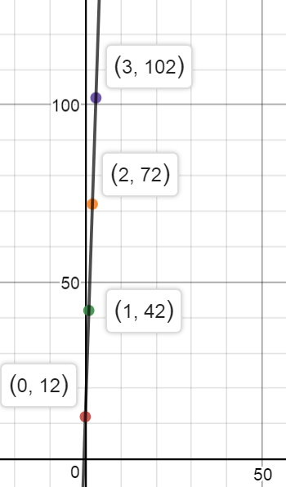
[1] The graph of c(t) at the right shows the cost of stock shares for a c(t) company (from a broker). Find the number of stock shares you can buy for $87.

[2] Write the equation for c(t) in slope-intercept form. cost

[3] Name the y-intercept of c(t) and explain what it represents.

[4] Graph the equation 3x – 5y = 30 and label the intercepts.

[5] Find the slope of 3x – 5y = 30.

[6] Describe the difference in the end behaviors of y = $-\frac{1}{2}$ x and y = 2x. shares

[7] Write the equation of the line that passes through (-2, 3) and (2, 0).

[8] Write the equation of the vertical line that passes through (2, -5); explain whether the line is a function along with your reasoning.

[9] Write the equation of the horizontal line that passes through (2, -5); explain whether the line is a function along with your reasoning.

[10] Rod has water that is 1.5 feet high in his pool, when he begins adding water, with a steady flow, at 10:00 a.m. At 10:20 the water is 1.75 feet high.

[10] (a) What is the rate at which the water rises, in feet per hour?

[10] (b) If he needs to stop the water flow when it reaches 6 feet high, at what time will he need to shut off the water?

[11] (a) Name the horizontal shift that takes y = 2x to y = 2(x – 3)? (b) Name the x-intercept of y = 2x and y = 2(x – 3).

_______________________________________________________________

Algebra II Lesson 2.1 Graphing and Interpreting Linear Functions

Here is a set of points that belong to a linear function: (-2, $\frac{3}{2}$), (-1, 1), (1, 0), (2, $-\frac{1}{2}$). The reason for calling the function linear is that, when you graph the points, they all lie on the same line.
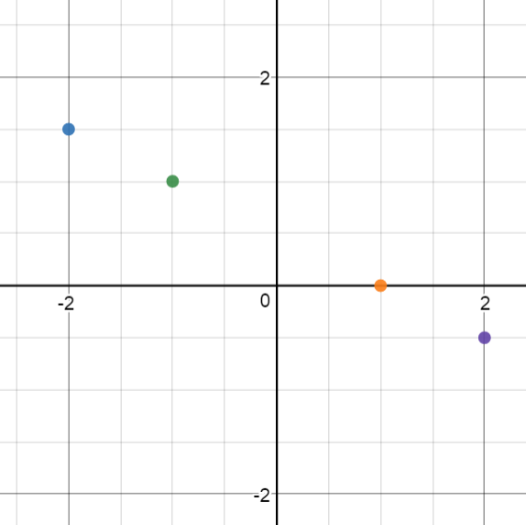
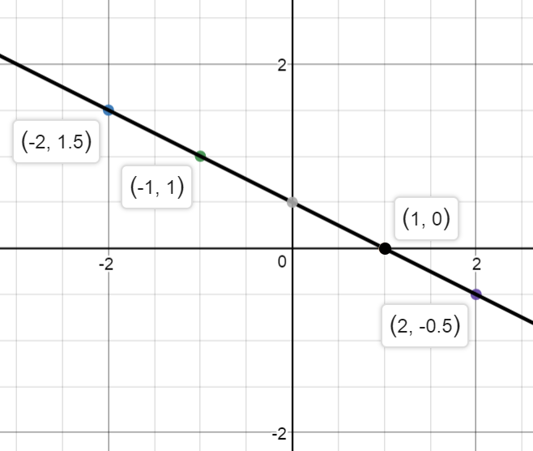

What really makes all four points line up is the fact that from any point to any other point, $\frac{∆y}{∆x}$ ($\frac{the change in y}{the change in x}$) is steady, is constant. From (-2, 1.5) to (-1, 1), $\frac{∆y}{∆x}$ = $\frac{-\frac{1}{2} down}{1 over}$ = $-\frac{1}{2}$ . Likewise, from (-2, $\frac{3}{2}$) to (2, $-\frac{1}{2}$), $\frac{∆y}{∆x}$ = $\frac{-2 down}{4 over}$ = $-\frac{1}{2}$ . We call this steady rate of change the slope, $-\frac{1}{2}$.

Many people complain about the difficulty of fractions. That means they need practice!

If you look at the line, it intersects the y-axis at (0, $\frac{1}{2}$ ). The y-intercept is $\frac{1}{2}$ .

Lots of students learn the importance of these facts; lots of other students learn and forget these facts. Because colleges and universities expect students to understand these concepts, you need to decide if you want—and need—more practice with them.

y = mx + b is known as slope-intercept form of a line, the form most math people use, for writing a linear equation. People use this form because it is really useful.

To graph a line in this form, start at b high on the y-axis. (Many people call b the starting point.) Next, follow the slope to the next convenient point of your graph: up or down according to the rise and over according to the run.

EXAMPLE 2.1 A Graph y = $\frac{2}{3}$x – 3.

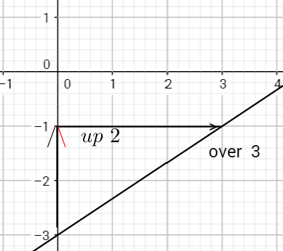
Solution: Start at (0, -3) on the y-axis, because b is -3.
Then follow the slope by going up 2, over 3, to reach
the next convenient point of your graph.

m = $\frac{2}{3}$ and b = -3.

EXAMPLE 2.1 B Graph y = -3x.

Solution: Start at b = 0: if there seems to be no b value, it must be zero. Next, follow the slope: -3 down and 1 over. (-3 = $-\frac{3}{1}$ .) *You should make sure you know what this graph looks like.

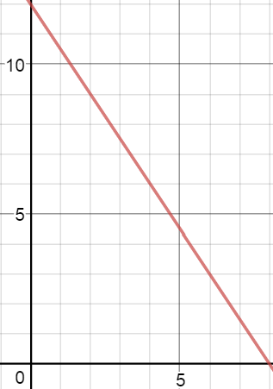
EXAMPLE 2.1 C Here is the graph of h(t), which shows the height of water in a storage tank—measured in meters—compared to time—measured in hours.

Find the height of the water at t = 4. h(t)

Find the time when the tank is empty.

Solutions: The point (4, 6) represents t = 4 hours and h(t) = 6 meters: the height is 6 meters at t = 4.
t
The point (8, 0) represents t = 8 hours and h(t) = 0 meters: the tank is empty at 8 hours.

To find slope, you can use the formula m = $\frac{y_{2}-y_{1}}{x_{2}-x_{1}}$ , which = $\frac{change y}{change x}=\frac{rise}{run}$.

SAMPLE QUESTIONS
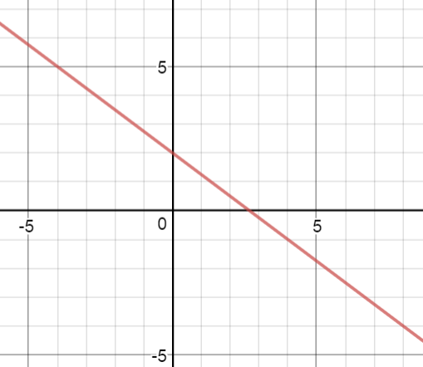
[1] Graph f(x) = -2x + 1. [2] Write the equation of the function g(x), which is graphed to
the right.

[3] Name the slope and the y-intercept of y = x.

[3.5] Do you like memes? Tsk tsk.

Algebra II Lesson 2.2 Naming and Manipulating Features of a Linear Function

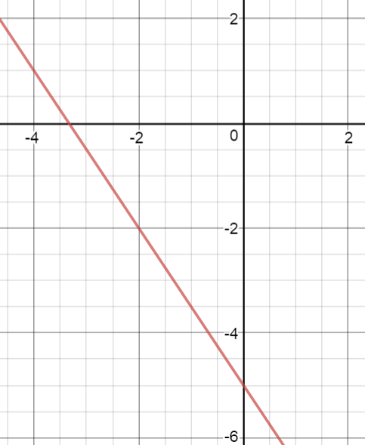
Look at the function f(x) = $-\frac{3}{2}$ x – 5. Suppose it were not graphed for you: how would you name its features? Ask a meme expert?

From any point to any other point, the slope goes down -3 and over 2—or it goes up 3 and over -2. Either way, the slope = $-\frac{3}{2}$ .

When x = 0, y = -5, so the y-intercept is -5.

Some bright meme follower might think the x-intercept is -3.5, BUT when y = 0, x = $-3.\overline{3}$ (otherwise known as $-\frac{10}{3}$ ). This is the x-intercept.

Because the slope is negative, as x becomes more positive, y becomes more negative, and vice versa; therefore, the end behavior is this: $\lim_{x→-∞}{-\frac{3}{2}x-5}=∞$ and $\lim_{x→∞}{-\frac{3}{2}x-5}=-∞$.

Because the slope is negative, f(x) continually decreases over the entire domain.

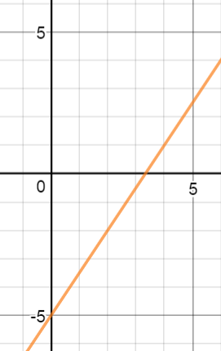
*Now, suppose you had to change this function so that its slope is positive $\frac{3}{2}$ , but you had to leave the y-intercept at -5: how will this change the graph and its other features?

If y = $\frac{3}{2}$ x – 5, then when y = 0, x = $\frac{10}{3}$ . The x-intercept is positive.

The end behavior will change: As x$-∞$, y$-∞$ and As x$∞$, y$∞$.

The function increases everywhere along the domain.

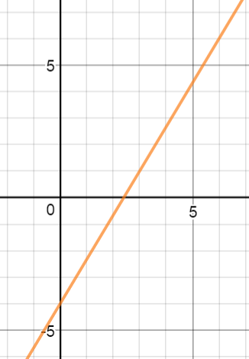
SAMPLE QUESTIONS
For the function graphed at the right, name the following features:
[4] the slope [5] the y-intercept [6] the x-intercept

[7] the domain [8] the range

[9] intervals of increasing and decreasing behavior

Algebra II Lesson 2.3 Forms of Linear Equations; y = k and x = k

How can you look at a function and instantly tell whether it is linear? Well, any function that can be written in slope-intercept form (y = mx+b) must be linear. IF you really want to know why, here you go (otherwise skip this and go to the next paragraph): If m and b are constants (non-changing numbers), and if y = mx + b, then when x = 0, y = b; if x = ANY OTHER NUMBER, y goes up or down in PROPORTION with x, and the proportional value is m. For example, if y = $\frac{3}{4}$ x – 2, when x = 0 then y = -2; when x = 1 then y = $\frac{3}{4}$ (1) – 2, so that as x climbs by 1, y climbs by
$\frac{3}{4}$ (1) ; when x = 5, y = $\frac{3}{4}$ (5) – 2, so that as x climbs by 5, y climbs by $\frac{3}{4}$ (5).

A linear function can appear in another form and still be rewritten in slope-intercept form.

A line can be written in standard form: Ax + By = C, where A, B, and C are integers. Standard form is useful for easily finding x- and y-intercepts.

A line can be written in point-slope form: y – y₁ = m(x – x₁). Point-slope form is useful when you know just one point and the slope of a line.

Here are examples of linear functions: y = x, y = 2x – 1, 3x – 5y = 12, y – 2 = $\frac{1}{2}$ (x + 4)

Many polynomial expressions have variables with exponents or roots, and many expressions have x multiplied by y and can be shown to be in the denominator of a rational expression: HOWEVER, such expressions cannot appear in a function.

Here are examples of NON-linear functions: y = 2x² – 1, xy = 4 (same as y = $\frac{4}{x}$ ) y = 3x – x⁻²
f(x) = $\sqrt[3]{2x-1}$
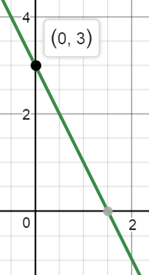
y = mx + b: Slope-intercept of a line form is useful for quickly graphing a line. For example, if y = -2x + 3, start at 3 high on the y-axis, then follow the slope: down 2 and over 1.

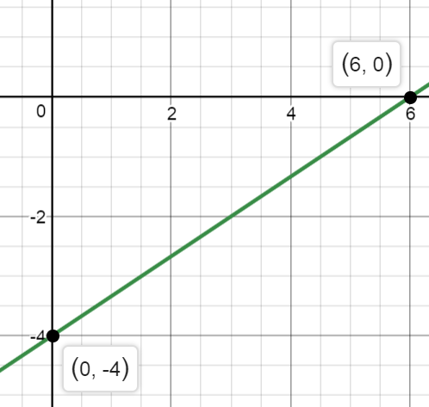
Ax + By = C: Standard form of a line is useful for quickly identifying the intercepts and making a graph. For example, suppose you need to graph 2x – 3y = 12. Find the x-intercept by making y = 0; when 2x – 3(0) = 12, the x-intercept must be 6. Find the y-intercept by making x = 0; when 2(0) – 3y = 12, the y-intercept must be -4. Draw the line that goes through both intercepts.

y – y₁ = m(x – x₁): Point-slope form of a line is useful when you know the slope and a single point. For example, suppose you know that a line has a slope of $\frac{1}{3}$ and passes through (-1, 2): the equation of that line is y – 2 = $\frac{1}{3}$ (x + 1)—the same as y – 2 = $\frac{1}{3}$ [x – (-1)].
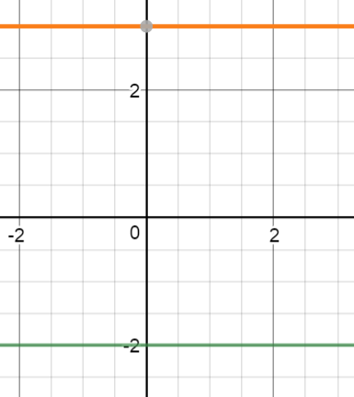
What if the slope of a line is zero? If so, then y = 0x + b, which means y = b. Every horizontal line has an equation in which y = a constant. To the right are the graphs of y = -2 and y = 3: both are linear constant functions.

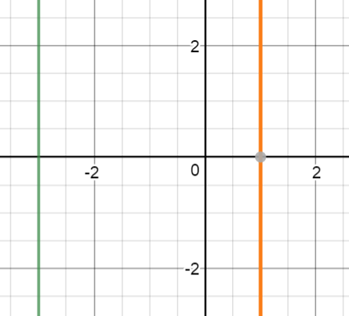
What if the slope is undefined? If so, then x = some constant. Every vertical line has an equation written this way, and every vertical line is NOT a function. To the right the lines x = -3 and x = 1 are graphed.

Be prepared to write a linear function in different forms.

EXAMPLE 2.3 A Write the line y + 4 = 3(x – 1) in slope-intercept form.

Solution: First distribute 3: y + 4 = 3x – 3; second, subtract 4: y = 3x – 3 – 4, so y = 3x – 7.

SAMPLE QUESTIONS

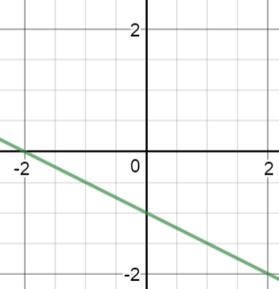
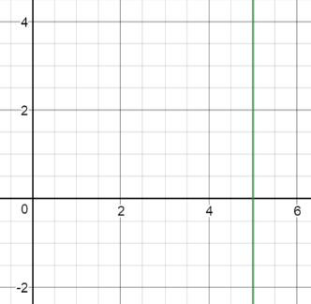
[10] Write the equation for each graph: [a] [b]

[11] Graph 3x + 4y = 24 and name important features.

Algebra II Lesson 2.4 Writing Linear Equations

When you are given enough information, you need to be able to write an equation that fits the information. Equations are boring, yeah, okay—but they are very useful.

Suppose an employee for Fillups Petroleum fills a 12,500-gallon capacity tank with oil: the container already has 200 gallons of oil, and 20 minutes after she begins putting in more oil, the tank measures 350 gallons full. The pump fills the tank at a regular rate.
She is expected to write an equation that relates time t in hours to capacity c(t) in gallons of oil.

The employee first calculates the rate (the slope): $\frac{350 gallons}{\frac{1}{3} hours}$ = 1,050 gallons per hour. You may wonder: what happened to 20 minutes? 20 minutes = $\frac{20 min}{60 min/hr}=\frac{1}{3}$ hours.

Since the tank began with 200 gallons, this is our starting amount (the y-intercept).

For this situation, c(t) = 1,050 t + 200. Why does any employee need to know this?

IF the tank holds a total of 12,500 gallons, the employee can use the equation to find when the pump should be turned off. [It would sure be nice if the pump turned itself off—but then, why would Fillups need the employee?]

IF the tank will be full at time x, when it holds a full 12,500 gallons, then 12,500 = 1,050x + 200. If you solve this for x, x = 10 hours.

IF you are given two points, be ready to name the equation that passes through both.

EXAMPLE 2.4 A Write the equation of the line that goes through (-3, 2) and (9, -6).

Solution: First find the slope: m = $\frac{y_{2}-y_{1}}{x_{2}-x_{1}}$ = $\frac{-6 - 2}{9-(-3)}$ = $\frac{-8}{12}= -\frac{2}{3}$ . Second, use point-slope form. You may use EITHER point: for now, let’s use (-3, 2): y – 2 = $-\frac{2}{3}$ (x + 3) y – 2 = $-\frac{2}{3}$ x – 2
y = $-\frac{2}{3}$ x. While you might leave the equation in point-slope form, notice that slope-intercept form is more convenient.

SAMPLE QUESTIONS

[12] A pharmacy has 1800 ounces of amoxicillin on day 5 (Sep. 5). Suppose the pharmacy uses a steady amount each day and on day 12 (Sep. 12) they have 1,212 ounces left. [a] Write an equation to fit this situation. [b] Find the day when the pharmacy will be out of amoxicillin.

[13] Write the equation of the line that contains (2, 5) and (4, 8).

Algebra II Lesson 2.5 Recognizing Patterns

How can you tell if a pattern is linear?

What makes any set of data linear is a steady rate of change—a constant slope.

Contrast these two sets of data:

When x = -2 | -1 | 0 | 4 | 6 | When x = -2 | -1 | 0 | 4 | 6 |
then f(x) = 5 | 3.5 | 2 | -4 | -7 | then g(x) = 1.5| 3 | 6 | 96|384|

For f(x), each time x increases 1, y decreases 1.5. If x increases by 4 (from 0 to 4), y decreases by 6, which is 4(1.5). If x increases by 2, y decreases by 3, which is 2(1.5). f(x) has a steady slope of -1.5. g(x) does not have such a steady rate of change.

Linear functions are examples of repeated addition: as one is added to x, the same amount is added to y.

EXAMPLE 2.5 A Find the thirtieth term of the arithmetic sequence: -11, -8, -5, -2, . . .

Solution: An arithmetic sequence always has a common addend: here the common addend is 3. (3 is added to get the next number in the sequence.) If you need the thirtieth term, consider finding the zeroth term: go backward 3 to get -14. This is our starting amount. Now add 30 sets of 3 to -14: 30(3) – 14 = 90 – 14 = 76. 76 is the 30th term.

SAMPLE QUESTIONS

[14] Is the following set of data linear? Explain your response.

When x = -3 | -1 | 0 | 1 | 3 |
then y = 4 | 9 | 11.5| 14 | 19 |

[15] Find the eightieth term in this sequence: -17, -13, -9, -5, . . .

__________________________________________________

Algebra II Lesson 2.6 Transformations of Linear Functions PLUS Putting It All Together

Hopefully you have already studied transformations in Geometry. The three types of transformations that preserve angle and distance are translations, reflections and rotations. Later this year we will add to that list shrinks and stretches.

Look at what happens to f(x) = 2x – 3 when you add 7:
When x = 0 | 1 | 2 | 100 | When x = 0 | 1 | 2 | 100 |
then 2x – 3 = -3 | -1 | 1 | 197 | then 2x – 3 + 7 = 4 | 6 | 8 | 204 |

Every point is raised by 7. This is a translation (a slide): T(x, y)(x, y + 7). In plain English, every point on f(x) is raised 7 steps.

NOW, here is another translation that may be harder to spot: look at what happens when you replace x with x + 2 in f(x):
When x = 0 | 1 | 2 | 100 | When x = -2 | -1 | 0 | 98 |
then 2x – 3 = -3 | -1 | 1 | 197 | then 2(x + 2) - 3 = -3 | -1 | 1 | 197 |

IF you look closely, you will see both functions have the same y values; however, each x value in the transformation is 2 steps negative compared to the corresponding x value in f(x): -2 is 2 left of 0; 98 is 2 left of 100; etc. Every point has been translated 2 steps left along the x-axis. This translation is the following: T(x, y)(x – 2, y).

Suppose a line is rotated 90º around a given point? Hopefully you learned in Geometry that two lines forming a right angle have opposite-reciprocal slopes.

EXAMPLE 2.5 A Name the transformation that takes g(x) = $-\frac{1}{2}$ x + 4 to h(x) = 2x.

Solution: Recognize that the transformation has a slope that is the opposite reciprocal of the original slope; therefore you can start by saying g(x) is rotated 90º around (0, 4). That gives you the line y = 2x + 4. Second, to get to h(x), you need to go down 4 steps. Here is the entire transformation: $\left(x, y\right)→(x, y-4)$ $°$ $R_{({90}^{o}, \left(0, 4\right))}$. *This is, symbolically, how to write the composition of two transformations: you translate the first transformation—which is a 90º rotation around (0, 4)—down 4 steps. You can probably see that the second transformation is written first: that is because the second is performed ON the first. That’s how mathematics rolls.

Really, just be prepared to explain transformations so that they make sense to you and others.

SAMPLE QUESTIONS

Name each transformation.

[16] a(x) to b(x) [17] c(t) to d(t) c(t) d(t)
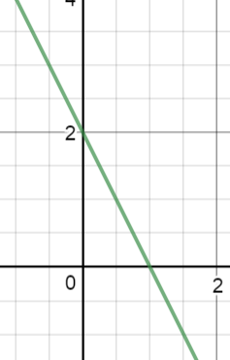
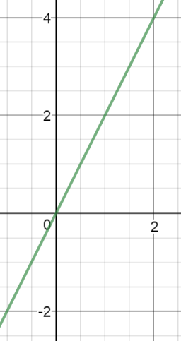
a(x) = 0.4x + 1
b(x) = -2.5x – 2

[18] e(x) to f(x)

e(x) = 2x + 1

f(x) = 2(x – 5) + 1

[19] Graph each equation and say whether each is a function. Explain your thinking.

[a] y + 1 = -4 [b] x + 2y = 9 [c] x = 3 [d] 3x - y + 5 = 0

[20] State which of the following are functions. [a] y = $\sqrt{x}$ [b] y² – x² = 4 [c] y = 0
Explain your thinking.

[21] Name the transformation that takes f(x) = x – 9 to g(x) = x + 1.

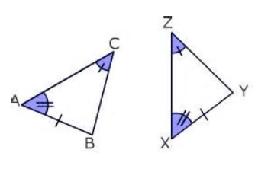
[22] By which theorem or postulate are the two triangles congruent?
Clearly state what triangles are congruent and name the postulate or theorem.

[23] Solve for n: 3 – n² = -24. Put your response in simplest form.

[24] State which of the following are linear functions. [a] x + 2 = 3 [b] x – 4y = 0

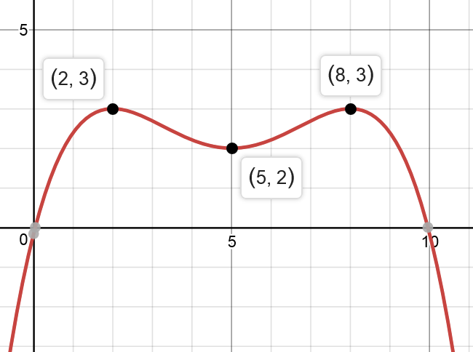
[25] The function g(x) is graphed at the right. State the following for g(x):

[a] any relative minima; [b] any relative maxima;

[c] any global minima; [d] any global maxima;

[e] the end behavior; [f] the domain;

[g] the range; [h] intervals of increasing behavior;

[i] any intercepts.

[26] [a] Graph 2x – 5y = -20. [b] State the intercepts of the function.

[c] State the slope of the function.

[27] A line passes through (2, 0) and (-1, 3). Write the equation of the line in slope-intercept form.

[28] Name the horizontal translation that takes f(x) = -0.5x + 2 to g(x) = -0.5(x + 4) + 2.

[29] A cooler is at 25º F at 9 a.m. when it begins warming. IF the temperature is 29º at 9:30 and IF the temperature rises at a steady rate, find the time when the temperature reaches 50º.

[30] Name the 50th term of this sequence: 85, 79, 73, 67, . . .
Algebra II Lesson 2.7 Solving Linear Equations

You should remember important steps for solving a linear equation: [a] simplify both sides; [b] get the unknown on one side; [c] get all known values on the other side, until you have your solution.

Example 2.7 A Solve for a: -2(5 – 3a) + 16 = $\frac{9}{2}$ a .

Solution: First, distribute -2: -10 + 6a + 16 = $\frac{9}{2}$ a Second, simplify the left side by combining like terms: 6a + 6 = $\frac{9}{2}$ a Third, subtract 6a. Realize that 6a = $\frac{12}{2}$ a: 6 = $\frac{9}{2}$ a - $\frac{12}{2}$ a , so
6 = $-\frac{3}{2}$ a Finally, undo the multiplied fraction by multiplying by the reciprocal:
$\frac{6}{1}$ ( $-\frac{2}{3}$ ) = $-\frac{3}{2}$ a ( $-\frac{2}{3}$ ) -4 = a.

SAMPLE QUESTION

[31] Solve: -19 – (2x – 7) – x = 12x – 17

SAMPLE QUESTION ANSWERS

Lesson 2.1
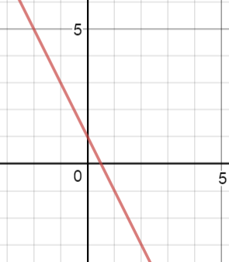
[1] Start at (0, 1), then go [2] The y-intercept is 2 and the slope
down 2 and over 1. goes down -3 and over 4.
y = $-\frac{3}{4}$ x + 2.

[3] Because y = x, the number
of x’s is 1; the added number
is 0. The slope = 1; the
y-intercept = 0.

Lesson 2.2
[4] The line passes through (0, -4) and (3, 1). The slope m = $\frac{rise}{run}= \frac{5 up}{3 over}= \frac{5}{3}$ .

[5] -4: when x = 0, y = -4.

[6] With the slope and y-intercept, the equation is y = $\frac{5}{3}$ x – 4. If you plug in y = 0 and solve for x, the x-intercept is $\frac{12}{5}$ (a.k.a. $6.\overline{6}$ ). If 0 = $\frac{5}{3}$ x – 4, add 4 to each side: 4 = $\frac{5}{3}$ x . Now multiply both sides by $\frac{3}{5}$ , to undo the fraction multiplied by x.

[7] The domain is the set of all real numbers $(-∞, ∞)$: the line goes forever left and right.

[8] The range is the set of all real numbers $(-∞, ∞)$: the line goes forever up and down.

[9] If you read the graph left to right, it climbs up: the function increases $(-∞, ∞)$.

Lesson 2.3
[10] (a) x = 5. The x-intercept is 5 and the slope is undefined. (b) y = $-\frac{1}{2}$ x – 1. The y-intercept is -1 and the slope goes $\frac{down-1}{over 2}$ . NOTE: This can also be written y = $\frac{-x}{2}$ – 1.

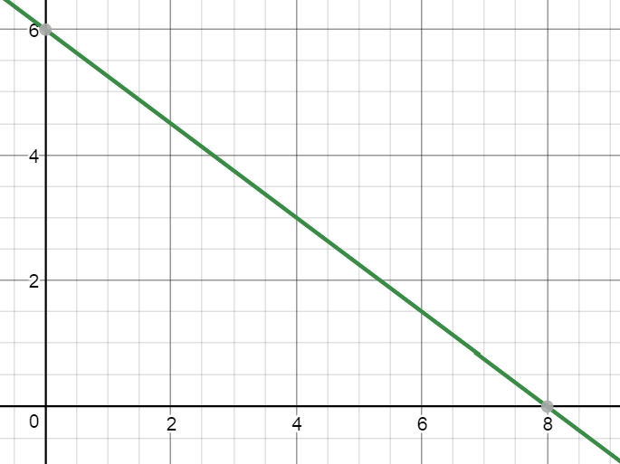
[11] For 3x + 4y = 24, when y = 0, the x-intercept is 8. When x = 0, the y-intercept is 6. Graph these points and connect them.

The domain is $(-∞, ∞)$. The range is $(-∞, ∞)$. The slope goes $\frac{down -3}{over 4}$ and so it is $-\frac{3}{4}$. The function goes down as you move left to right, so it decreases in the interval $(-∞, ∞)$.

Lesson 2.4
[12] [a] First find the rate of change (the slope): $\frac{1212-1800 ounces}{12-5 days}$ = $\frac{-588 oz}{7 days}= -\frac{84 oz}{day}$ . Second, use the slope and the point (5th day, 1800 oz.) to write y – 1,800 = – 84(x – 5). Now put this in slope-intercept form: y – 1,800 = –84x + 420 y = –84x + 2,220. Here is what the equation means: On day 0 (Aug. 31), the pharmacy had 2,220 ounces of medicine, and they sold about 84 ounces per day. [b] To find the day when they will run out of medicine, plug in 0 ounces for y, then solve for x: If 0 = –84x + 2,220, subtract 2,220 and then divide by -84: x $≈$ 26.4. On September 27 they will run out of medicine.

[13] The slope = $\frac{8-5}{4-2}$ = $\frac{3}{2}$ . If you use the point (2, 5) and the slope, y – 5 = $\frac{3}{2}$ (x – 2) in point-slope form. y – 5 = $\frac{3}{2}$ x – 3, so y = $\frac{3}{2}$ x – 3 + 5 y = $\frac{3}{2}$ x + 2.

Lesson 2.5
[14] This data set has a steady rate of change of $\frac{5}{2}$ , the same as 2.5. When x increases by 2, y increases by 5; when x increases by 1, y increases by $\frac{5}{2}$ . If you graph the data, you will see the points all fit a linear function.

[15] The common addend is 4. The 0th term is -21 (4 down from the 1st term). The equation that fits the pattern is y = 4x – 21. When x = 80, y = 299, and this is the 80th term.

Lesson 2.6
[16] The slope of a(x) = 0.4, which is $\frac{2}{5}$ as a fraction; the slope of b(x) = -2.5, which is $-\frac{5}{2}$ as a fraction. Because the slopes are opposite reciprocals, the two lines are perpendicular (form right angles). 1st rotate a(x) 90º; 2nd take the y-intercept from 1 to -2: in other words, translate 3 steps down.

[17] The slope of c(t) = 2 while the slope of d(t) = -2. 1st reflect c(x) across the y-axis; 2nd translate up 2.

[18] Plug 0 into e(x) and plug 5 into f(x): for both points you get y = 1. Try plugging 2 into e(x) and 7 into f(x): in both cases you get y = 5. Every point on e(x) is translated right 5 steps to become a point on f(x).

[19] [a] y + 1 = -4 [b] x + 2y = 9 [c] x = 3 [d] 3x - y + 5 = 0
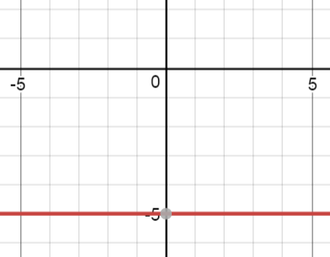
y = -5 IS a function. This IS a function. This is NOT a function. y = 3x + 5 IS a function.
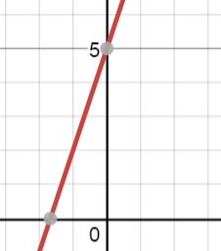
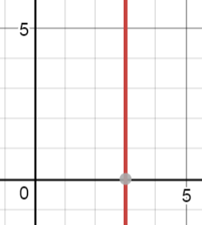
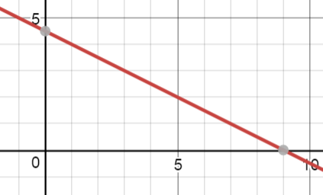

[20] (a) This is a function: for each x, there is only one y. (b) This is not a function: when x is 0, for example, y can be 2 or -2. If you graph the equation, you get a circle, which does not pass the vertical line test. (c) This is a function: for each x, there is only one y.

[21] When you change the -1 to a +9, every y value will be 10 greater: the transformation that takes f(x) to g(x) is a translation of 10 up.

[22] $∆$ABC $≈∆$ XYZ by the Angle-Angle-Side Theorem. Two pairs of angles and one pair of non-included sides are congruent.

[23] 3 – n² = -24 1st subtract 3: – n² = -27 2nd, ÷ (-1): n² = 27 3rd take square root:
n = + $\sqrt{27}= ±\sqrt{9} ·\sqrt{3}$ = $±3\sqrt{3}$ .

[24] [a] x + 2 = 3 is the same as x = 1: this is a vertical line, which does NOT pass the vertical line test, so this is not a function. [b] x – 4y = 0 is the same as y = $\frac{1}{4}$ x, with a slope of $\frac{1}{4}$ and a y-intercept of 0. This passes the vertical line test, so it is a function.

[25] [a] (5, 2) is a local low point, so 2 is a relative minimum. [b] There are absolute maxima but no local maxima. [c] There is no absolute lowest point, so there are no absolute minima.
[d] The two highest points are each 3 high, so 3 is the absolute maximum. [e] As x goes more negative, y goes farther down: $\lim_{x→-∞}{g(x)}= -∞$; as x goes more positive, y goes farther down: $\lim_{x→∞}{g(x)}= -∞$. [f] The curve continues forever right and left, so the domain is $\left(-∞,∞\right).$ [g] The curve goes down forever but only goes as high as 3, so the range is $(-∞, 3]$. [h] As a roller coaster going left to right, the curve goes up for $-∞$ < x < 2 and for 5 < x < 8, so intervals of increase are $\left(-∞, 2\right)$ and $(5, 8)$. [i] The y-intercept is 0; the x-intercepts are 0 and 10.
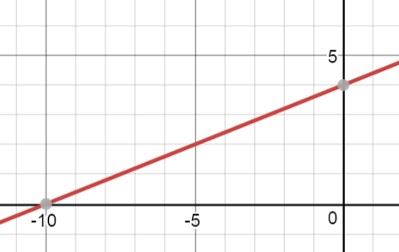
[26] For 2x – 5y = -20, when y = 0, x = -10; when x = 0, y = 4. These are the intercepts. Connect them to make your graph.

[27] The line through (2, 0) and (-1, 3) has a slope that goes UP 3 (from y = 0 to y = 3) and OVER -3 (from x = 2 to x = -1). $\frac{Δy}{Δx}$ = $\frac{-3}{ 3}$ = -1.
IF you use this slope and (2, 0), then in point-slope form the equation is y – 0 = -1(x – 2). In slope-intercept form this is
y = -x + 2.

[28] Contrast several points for f(x) = -0.5x + 2 and g(x) = -0.5(x + 4) + 2:
When x = 0 | 2 | 4 | 5 | 6 | When x = -4 | -2 | 0 | 2 | 4 |
then f(x) = 2 | 1 | 0 | -½ | -1 | then g(x) = 2 | 1 | 0 | -1 | -2 |

(0, 2) on f(x) gets moved 4 steps left to be (-4, 2) on g(x). (2, 1) on f(x) gets moved 4 steps left to be (-2, 1) on g(x). (4, 0) on f(x) gets moved 4 steps left to be (0, 0) on g(x).
**The transformation, taking f(x) to g(x), is T(x, y)(x – 4, y), a translation 4 steps left.

[29] Given that the cooler starts at 25º F at 9 a.m., call 9 a.m. our time t = 0 (start time), and let h(0) = 25º be the starting temperature for the function h. The temperature rises 4º in half an hour (from 25º to 29º), so it must rise 8º per hour. Our linear function is this: h(t) = 8t + 25. Next, we need t when h = 50º; therefore, substitute 50 for h and solve for t: 50 = 8t + 25 Subtract 25: 25 = 8t Divide by 8: $\frac{25}{8}$ = t, so at t = 25 ÷ 8 = 3.125 hours after 9 a.m. (which is 12:07 p.m. + 30 seconds), the cooler will be at 50º.

[30] In each step you subtract 6. If the first term is 85, the 0th term is 85 + 6, which is 91. (Going backwards means doing the inverse of subtraction.) To find any term, y = 91 – 6x, because the starting term (0th term) is 91, and from there you repeatedly subtract 6. The 50th term = 91 – (50)(6) = -209.

[31] To solve -19 – (2x – 7) – x = 12x – 17, first simplify: -19 – 2x + 7 – x = 12x – 17
-12 – 3x = 12x – 17 Next, get all x’s on one side by adding 3x: -12 = 15x – 17 Third, add 17 to both sides: 5 = 15x Finally, divide by 15: $\frac{5}{15}$ = $\frac{1}{3}$ = x.

Algebra II U 2-1 UNIT 2, DAY 1 TRACKING ZOMBIES Put all responses on this paper.

The Zombie Apocalypse has begun. You, your family and friends have constructed a fortress to keep out zombies. Your job is to use an old military radar tracker to watch for zombies that come within 5 miles of your fortress. You and your group have enough weapons to fend off 1-5 zombies in a single assault, but if more than five zombies attack you at once, you will need to flee.

Suppose one day you view the following zombies hordes on your radar screen. You need to do two things: [a] decide which zombies are headed for your fortress; [b] decide how many zombies will attack you at any one time. Put your work and explanation at the bottom of the page.

Zombie Horde Alpha: This zombie group has FOUR zombies: the horde is at
(-1.8 miles west, -3.15 miles south) at 9 a.m. Later this horde is at (-1.4 miles west, -2.45 miles south) at 10 a.m. Your fortress is at (0, 0).

Zombie Horde Beta: This zombie group has THREE zombies: the horde is at
(-4 miles west, 3.2 miles north) at 9 a.m. Later this horde is at (-3 miles west, 2.4 miles north) at 10:30 a.m.

Zombie Horde Gamma: This zombie group has EIGHT zombies: the horde is at
(-3.2 miles west, -4.8 miles south) at 9 a.m. Later this horde is at (-2.2 miles west, -4.2 miles south) at 11 a.m.

Zombie Delta: This is ONE zombie, which is at (1.8 miles east, 1.08 miles north) at 9 a.m. Later this zombie is at (1.2 miles east, 0.72 miles north) at 10 a.m.

Algebra II UNIT 2, DAY 2 NOTES 2.1, 2.2, 2.3

[2.1] Be able to graph, and interpret the graph, of a linear function;
[2.2] be able to name and manipulate the features of a linear function: slope, intercepts, end behavior, etc.;
[2.3] be able to recognize a constant function as y = k, where k is a constant; be able to recognize a linear function in any form (standard, slope-intercept, point-slope, etc.); be able to recognize a vertical relation as x = k, where k is a constant.

Linear functions can be written in many forms. However, all linear functions have a common construction: in whatever form they appear, they can be rewritten in SLOPE-INTERCEPT form: y = mx + b.
This is probably the most useful form.

As long as m (slope) and b (y-intercept) are constants, then as x increases by 1, y increases by m (the same, steady amount):

For f(x) = 2x – 3, when x = -1 | 0 | 1 | 3 | 6 | As x 1,
then f(x) = -5 | -3 | -1 | 3 | 9 | y 2

For g(x) = $-\frac{2}{5}$ x , when x = -5 | 0 | 5 | 10 | 20 | As x 5,
then g(x) = 2 | 0 | -2 | -4 | -8 | y -2

For y = mx + b, when x = -1 | 0 | 1 | 2 | 4 | As x 1
then y = -m+b| b | m+b | 2m+b | 4m+b | y b

Here are several y = x, h(x) = -15x + 70, 2x – 7y = 21
linear functions:
y – 8 = $\frac{1}{3}$ (x + 2)
All of these can be rewritten in y = mx + b form.

Here are several j(x) = $\sqrt[3]{2x-1}$ , x² – y² = 25, y = $\frac{1}{x}$
NON-linear functions:
y = -5x³ – 2x + x⁻¹, xy = 8

IF x or y are taken to a power other than 1, OR IF x or y have a root taken, OR IF x or y can be written in the denominator of a fraction, then the function is NOT linear.

_______________________________________________

- What does “slope” mean?

- Define $\frac{Δy}{Δx}$ .

- What is an intercept?

Here are two other important forms of a linear function:

Standard form:

Point-slope form:

______________________________________________

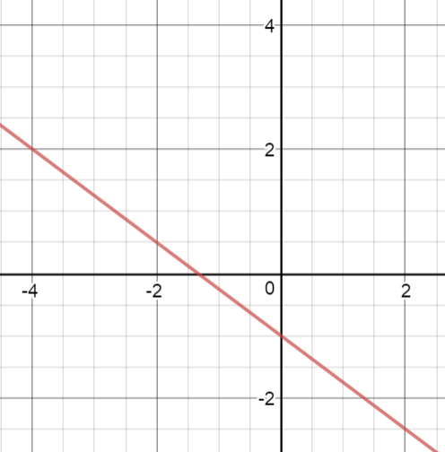
Examine f(x) = $-\frac{3}{4}$ x – 1.
Name the following:

[a] domain
[b] range
[c] intercepts
[d] increasing and
decreasing behavior
[e] end behavior

How do these features change when the slope becomes positive?

Which is greater, f(10) or f(20)? EXPLAIN your thinking.

Graph each of the following, and state whether each is *a constant function, *a non-function, *a linear function.

[A] y – 4 = 5 [B] x – y = 5 [C] x – 4 = 5

Algebra II U 2-2 Line of Broken Dreams Put all responses on this paper.

[1] Explained what you know so far about the following:

[a] slope:______________________________________________________________________

______________________________________________________________________________

[b] y = mx + b:__________________________________________________________________

______________________________________________________________________________

[c] point-slope form:_____________________________________________________________

______________________________________________________________________________

[d] standard form:______________________________________________________________

______________________________________________________________________________

[2] Graph the following. ALSO state the slope and intercepts.

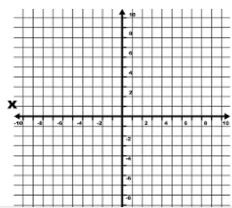
[a] f(x) = -x + 5 [b] 3x – 5y = 30 [c] x = -2
Slope:__________ Slope:__________ Slope:_________

Intercepts:___________ Intercepts:___________ Intercepts:___________

[3] Let’s hope you remember the Pythagorean Theorem from Geometry. Given $∆$QRS with m/ Q = 90º, RS = 12 cm and QS = 4 cm, find QR in simplest radical form.

QR = __________
[4] Suppose $∆$QRS is dilated with center Q and dilation factor 2.5. Explain what changes will happen to each side and each angle.

______________________________________________________________________________

______________________________________________________________________________

______________________________________________________________________________

______________________________________________________________________________

[5] Given g(x) = $\frac{x}{4}$ + $\frac{1}{2}$ , answer the following:

[a] Which is less, g(-2) or g(-3)? Explain. _____________________________________________

______________________________________________________________________________

[b] What is the x-intercept?________________

[c] As x decreases, what does y do? Explain.__________________________________________

______________________________________________________________________________

[d] Are there any minima or maxima for g(x)? Explain.__________________________________

______________________________________________________________________________

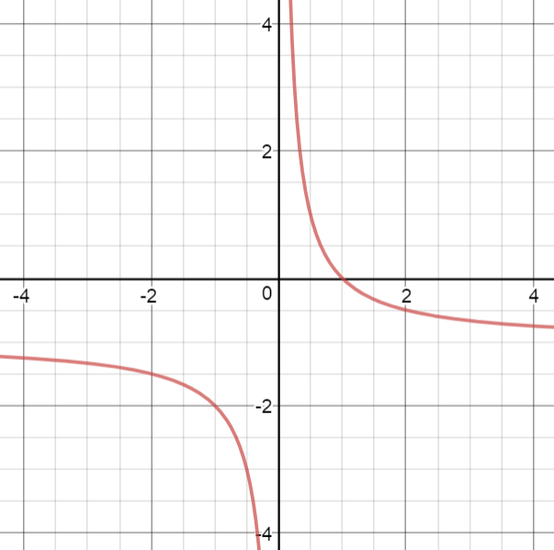
[6] Given the graph of h(x) = $\frac{1}{x}$ – 1, name the following:

[a] domain:________________ [b] range:_________________

[c] end behavior:________________________________________

______________________________________________________

[d] intervals of increasing behavior:_________________________

[7] [a] Is h(x) = $\frac{1}{x}$ – 1 linear? _______________ [b] Is h(x) a function?

Algebra II UNIT 2, DAY 3 Water Contamination

Rio Grande County in Colorado is the region most recently affected by massive water contamination. An old mine’s waste polluted river and ground water more than a month ago; county residents still cannot use their own water safely.

Suppose Rohnert Park’s water was polluted and you had to monitor the clean-up job. Imagine you are monitoring the filter system, and you notice the following:

Time Percent of Contamination
Day 1, 11:00 am 100%

Day 1, 11:00 pm 99.3%

Day 2, 11:00 pm 97.9%

Day 3, 11:00 am 97.2%

People ask every day when the river will be completely clean. Your job is to answer them honestly. When will the river be completely clean?
______________________________________________________
Algebra II Check for Understanding 2-3

1] What equation fits the following pattern of account balance over time?

When t = | -1 | 0 | 1 | 2 | 3 | 5 |
then b = | | | $60 | $72 | $84 | $108 |

*What should be the shape of the graph of your equation?

2] Graph f(x) = -2x + 3 and its inverse function on the same set of axes. Label each function on your graph.

3] For 3x – 6y = 6, find $\frac{Δy}{Δx}$ ( $\frac{change in y}{change in x}$ ) and the x-intercept.
Algebra II U 2-4 Estimated Time of Arrival © worksheet below

Have students in pairs. Give student the instructions for the activity.

INSTRUCTIONS: You will be given two points in the flight path of a plane flying in a linear ascent or descent. Use the two points to find the slope, equation and estimated time of arrival for the plane.

Example: At 10:00 a.m., Delta Flight 419 was at 15,000 feet; at 10:20 a.m. the flight was at 18,000 feet. Find the following:
[a] the slope comparing height to time,
[b] the equation that compares height in feet to time in hours,
[c] the time when the plane reached 30,000 feet.

Solution: [a] slope = $\frac{y_{2}- y_{1}}{ x_{2}- x_{1} }= \frac{18,000 ft.-15,000 ft.}{20 min.}$ = 150 feet/minute
[b] equation: h(t) = 150t + 15,000, where t = time in minutes past 10:00 a.m.
and h(t) = height in feet at time t.
[c] When h(t) = 30,000 feet, 30,000 = 150t + 15,000, so t = 100 minutes past 10:00 a.m., which is 11:40 a.m.

Now you and your partner answer the following questions:

[1] At noon, Air Canada Flight 6024 was at 26,000 feet, descending to an airport; at 12:15 p.m. the flight was at 23,000 feet. Find the following:
[a] the slope comparing height to time,
[b] the equation that compares height in feet to time in minutes,
[c] the time when the plane reached the airport.

_________________________________

[2] At 1:30 p.m., Delta Flight 280 was at 8,000 feet; at 1:40 p.m. the flight was at 10,400 feet. Find the following:
[a] the slope comparing height to time,
[b] the equation that compares height in feet to time in minutes,
[c] the time when the plane reached 35,000 feet.

Algebra II U 2-4 Connect the Dots Put all work and responses on another paper.

For each pair of points, [a] make a graph and connect the points with a line, [b] find the slope of the line, [c] write the equation of the line, [d] name the x-intercept and y-intercept of the line.

Example: Graph the line passing through (2, -3) and (4, 0). Find the line’s slope. Write the equation and name the intercepts.

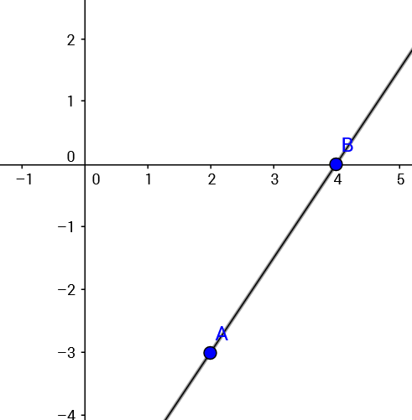
Example Solution:

The slope = $\frac{0-(-3)}{4-2}$ = $\frac{3}{2}$

The equation is y = $\frac{3}{2}$ x – 6.

The x-intercept is (4, 0) and the
y-intercept is (0, -6).

1] Graph the line passing through (-2, 1) and (2, -3). Find the line’s slope. Write the equation and name the intercepts.

2] Graph the line passing through (1, 3) and (4, 1). Find the line’s slope. Write the equation and name the intercepts.

3] Graph the line passing through (-1, -1) and (1, 5). Find the line’s slope. Write the equation and name the intercepts.

4] [a] For f(x) = 2(1.5)^{X – 1} complete the following x, y pairs: (-10, ?), (-1, ? ), (0, ?), (1, ?), (3, ?), (4, ?)

[b] Graph your x, y pairs and connect them.

[c] Is f(x) linear? JUSTIFY your response.

[d] Describe the end behavior of f(x): As x gets more negative, f(x) does what, and as x gets more positive, y does what?

Algebra II UNIT 2 NOTES 2.3 Forms of Linear Equations
Continued

Typically, the equation of a line can be written in at least three forms:

Slope-Intercept Form: y = mx + b : This form is useful for finding the slope and the y-intercept, and for making a quick graph.

Example: y = - $\frac{2}{3}$ x + 1 To start graphing, plot the y-intercept (0, 1); then go down 2 and over 3 to graph the next point.

Standard Form: Ax + By = C : The x’s + the y’s = the units, and A, B and C are all integers. This form is useful for finding and graphing the intercepts.

Example: 2x – 5y = 30 The x-intercept is where y = 0: (15, 0).
The y-intercept is where x = 0: (0, -6).

Point-Slope Form: y – y₁ = m(x – x₁) : This form is convenient if you know the slope and one point of a line.

Example: If a line has a slope of ½ and contains (-2, 5), the equation is
y – 5 = ½ (x + 2).

Algebra II U 2-5 A Line Up of Suspects Put all work and responses on another paper.

1] [a] What form is this equation in? $20x + $30y = $120,000
Suppose the equation represents $120,000 worth of tickets that are sold for a concert; also suppose x = number of people under age 18 who attended and y = number of people 18 and older who attended.

[b] What was the price of a ticket for someone under age 18?

[c] Pretend no adults attended the concert: How many people under age 18 would have attended?

[d] Pretend no people under 18 attended the concert: How many adults would have attended?

[e] Explain why standard form of a linear equation helps you find the x-intercept for a line.

2] [a] Graph x = 3 and label any intercepts. [b] What is the slope of x = 3?

3] [a] Graph y = 3 and label any intercepts. [b] What is the slope of y = 3?

4] Line A contains (2, -1) and has a slope of $\frac{3}{4}$ . [a] Write the equation of line A in point-slope form.
[b] Graph the line. [c] Name the domain and range.

5] [a] Graph y - 1 = -2 and label any intercepts. [b] What is the slope of y – 1 = -2?

6] What use is y = mx + b when you need to graph a line?

7] Suppose Ami borrowed several thousand dollars years ago, in order to pay off a business loan.
She took out the loan for $72,000 on June 1 of 2013. On July 1, 2013, she made a payment and then owed $71,150. On August 1, 2013 she made the same payment and then owed $70,300.

[a] Write an equation that models her debt. Represent her debt as a negative amount. Let x = the number of months after June 1, 2013 (so that her debt = -$72,500 at June, 2013); let y = her debt for any month x.

[b] Graph your equation. [c] Find the month and year when Ami will have made her last payment.

8] Suppose a banker writes a function to calculate the amount owed a customer. The customer deposits $250 on September 1 of this year. The customer’s account has $255 on November 1; the account has $262.50 on February 1 of the next year; the account has $265 on March 1 of next year.

[a] Let t = time in months past September 1 of this year; let b = the account balance at time t.
WRITE an equation that relates b to t.

[b] Find the balance on December 1 of next year. [c] Find the month and year when the balance
will be $300.
Algebra II UNIT 2, DAY 6 NOTES 2.4, 2.5, 2.6

[2.4] Be able to write the equation of a constant or linear function given its graph or sufficient features, such as two points, or given a realistic scenario in which $\frac{∆y}{∆x}$ (the rate of change) is steady;
[2.5] be able to recognize a pattern as either linear or nonlinear;
[2.6] perform and explain transformations of linear functions.

[1st] Write the equation of the line that contains (-1, 4) and (5, 2).

[2nd] A dam will overflow when the reservoir rises to the top. Last winter the water came to 3 feet from the top on January 6. On January 15 the water came to 2.4 feet from the top.
- Write an equation that relates t time in days to f(t) distance in feet that the water was from the dam top. Let t = 0 on December 31 of last year.
- Name the rate of change $\frac{Δf}{Δt}$ .
- If the water rose at a steady rate, on what day did the water crest the dam? Show your thinking.

[3rd] Which patterns are arithmetic (linear)? Which are non-arithmetic? Show your thinking.

[a] -8, -5, -1, 4, . . . [b] -8, -5, -2, 1, . . . [c] $\frac{2}{3}$ , 2, $\frac{10}{3}$ , $\frac{14}{3}$ , . .

_______________________________________________

Transformations

4] What transformation takes $∆$ ABC to $∆$ DEF?

A = (3, 2), B = (0, 4), C = (1, -2) D = (2, 3), E = (4, 0), F = (-2, 1)

5] What transformation takes y = 3x + 2 to y = $-\frac{x}{3}$ ?

6] What transformation takes y = -3x + 1 to y = -3x – 1?

7] What horizontal transformation takes f(x) = 2x + 1 to
g(x) = 2(x – 3) + 1?

8] Explain the transformation that takes y = -3x + 1 to y = 3x – 1.

Algebra II U 2-6 SHIFTY BEHAVIORS ALPHA Transforming Linear Functions
Put all work and responses on graph paper.

For questions 1-4, state the transformation that takes the first function to the second function or relation.

[1] f(x) = 0.5x – 7 to g(x) = -0.5x + 2 [2] y = 0.5x + 1 to y = -2x – 2

[3] a(x) = x + 3 to b(x) = -x [3] y = 2 to x = -3

For 5-10, FIRST, graph each PAIR of functions; put each function on its own set of axes. (That means for each problem, make a separate graph for [a] and a separate graph for [b]. Do NOT put [a] and [b] on the same set of axes.)
SECOND, name the x-intercept and y-intercept for each function.
THIRD, EXPLAIN in 1-2 sentences the transformation that takes [a] to [b]. Specifically, say how [a] needs to be shifted left or right, in order to be [b]. (HINT: Look at what changes for the x-intercept; also notice what x is when x = 1—notice the change in x from [a] to [b].)

5] [a] y = $\frac{-1}{ 2}$ x [b] y = $\frac{-1}{ 2}$ (x + 3) 6] [a] y = 3x [b] y = 3(x + 2)

7] [a] y = $\frac{3}{ 2}$ x + 1 [b] y = $\frac{3}{ 2}$ (x – 4) + 1 8] [a] f(x) = -x + 3 [b] g(x) = -(x – 1) + 3

9] [a] y = -2x + 5 [b] y = -2(x + 1) + 5 10] [a] h(x) = 4x – 3 [b] j(x) = 4(x – 2) – 3

11] Suppose y = 3x + 5 is changed to be y = 3(x + n) + 5.

[a] If n is positive, what transformation takes the original function to the changed function?

[b] If n is negative, what transformation takes the original function to the changed function?

12] [a] Find the 40th term of this sequence: 81, 74, 67, 60, . . . [b] Explain whether the sequence is arithmetic (linear) or not.

13] By August 15 of this year, an industrial smoke stack had emitted 217.5 tons of CO₂. By August 30 of this year, the smoke stack had emitted 220.5 tons of CO₂. [a] Name the rate at which CO₂ is released, in tons per day. [b] Let d = days past August 15 and let t(d) = tons of CO₂ emitted: write an equation relating t(d) to d. [c] Find the total CO₂ the smoke stack will have emitted by January 1 of next year.

14] Given Q = (-2, 5), R = (1, 4), S = (-1, 0); given T = (-3, -5), U = (0, -4), V = (-2, 0); name the transformation that takes $∆$QRS to $∆$TUV.

Algebra II U 2-7 Performance Task UNIT 2
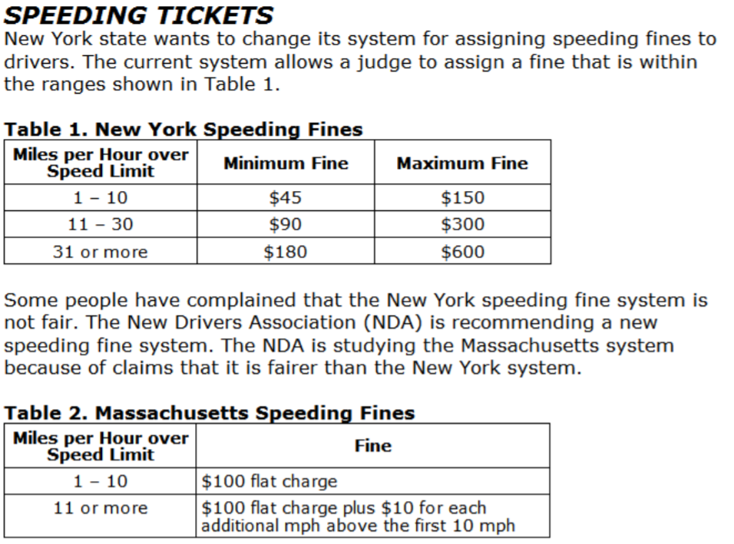
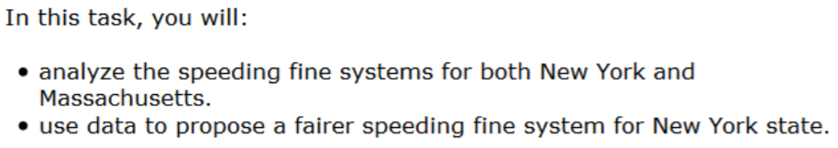

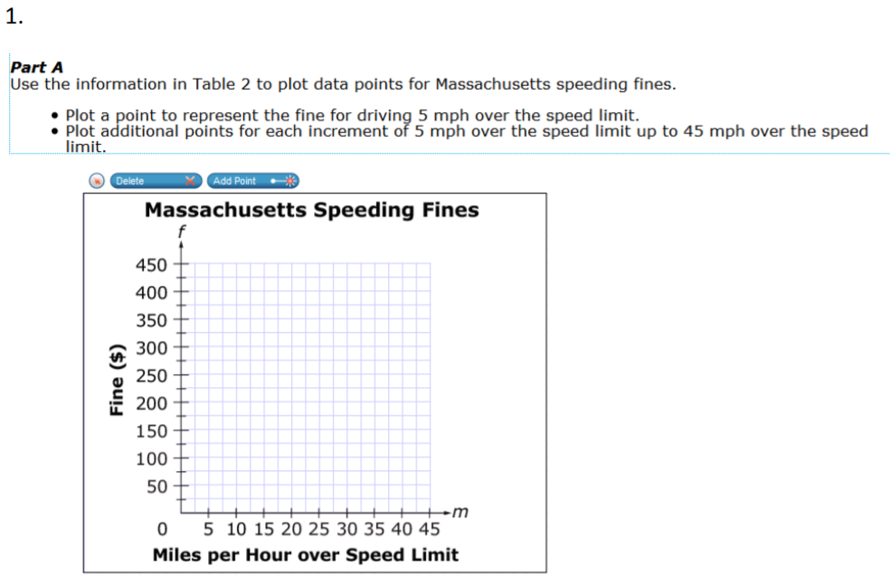

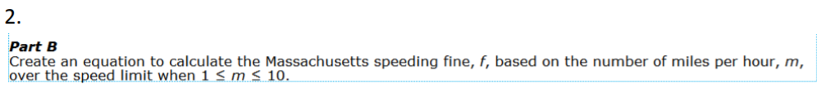

_________________________________

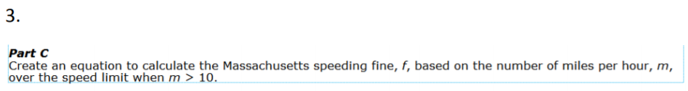

_________________________________

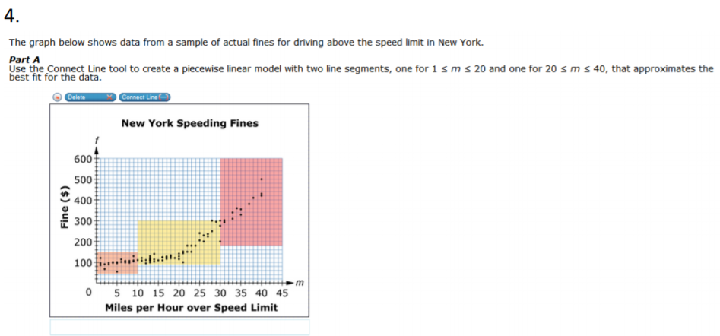

[a] Draw the two line segments that best fit the data in the graph.

[b] Write a piecewise equation that relates x miles per hour over the speed limit to f fine.

[c] Explain how you thought out your piecewise function.

Algebra II UNIT 2 Review Put all work and responses on another paper.
Begin with question 16. Answer every question first: solutions can be found on my website.

Name each transformation.

[16] a(x) to b(x) [17] c(t) to d(t) c(t) d(t)
a(x) = 0.4x + 1
b(x) = -2.5x – 2

[18] e(x) to f(x)

e(x) = 2x + 1

f(x) = 2(x – 5) + 1

[19] Graph each equation and say whether each is a function. Explain your thinking.

[a] y + 1 = -4 [b] x + 2y = 9 [c] x = 3 [d] 3x - y + 5 = 0

[20] State which of the following are functions. [a] y = $\sqrt{x}$ [b] y² – x² = 4 [c] y = 0
Explain your thinking.

[21] Name the transformation that takes f(x) = x – 9 to g(x) = x + 1.

[22] By which theorem or postulate are the two triangles congruent?
Clearly state what triangles are congruent and name the postulate or theorem.

[23] Solve for n: 3 – n² = -24. Put your response in simplest form.

[24] State which of the following are linear functions. [a] x + 2 = 3 [b] x – 4y = 0

Continue on the back.

Review 2

[25] The function g(x) is graphed at the right. State the following for g(x):

[a] any relative minima; [b] any relative maxima;

[c] any global minima; [d] any global maxima;

[e] the end behavior; [f] the domain;

[g] the range; [h] intervals of increasing behavior;

[i] any intercepts.

[26] [a] Graph 2x – 5y = -20. [b] State the intercepts of the function.

[c] State the slope of the function.

[27] A line passes through (2, 0) and (-1, 3). Write the equation of the line in slope-intercept form.

[28] Name the horizontal translation that takes f(x) = -0.5x + 2 to g(x) = -0.5(x + 4) + 2.

[29] A cooler is at 25º F at 9 a.m. when it begins warming. IF the temperature is 29º at 9:30 and IF the temperature rises at a steady rate, find the time when the temperature reaches 50º.

[30] Name the 50th term of this sequence: 85, 79, 73, 67, . . .

