Geometry Lesson 1-1 Objective: Students will explore constructions with a compass and straightedge and explore measurement tools.
__________________________________________________
GEOMETRY NOTES 1-1: Measurement and Distance

[1st] What letter is halfway
between A and U in the alphabet?

[2nd] What letter is three-fourths
of the way from A to U in the alphabet?
What strategies can you use to find out?

[3rd] Which is closer to A, B C
B or C? . .

How can we know for sure?
.
A

[4th] Can you list at least three
different methods we can use
to know which is closer?

[5th] List at least two different
functions of a compass.
________________________________________________
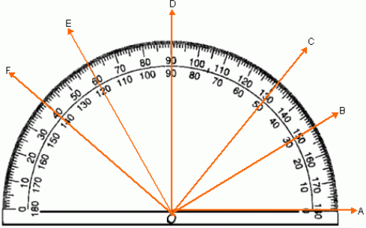
[6th] Find the measure of each angle in degrees:

/ AOE
/ AOC
/ BOA
/ DOC
/ FOD

_____________________
To the right is an expanded U V
image of a tape measure.

[7th] Into how many parts is
one inch divided on a tape
measure? How does this
affect the way we measure
in inches? _____________
W X
[8th] How long is $\overline{UV}$?

[9th] How long is $\overline{WX}$?

