Geometry Lesson 1-10: Students will copy a triangle and construct a parallelogram; they will also define skew lines, coplanar and noncoplanar points.
_______________________________________________

[1st] Can you complete the magic square?
| 4 | | |
| | | |
| 3 | 5 | |
| | | |
| 8 | | 6 |
| | | |

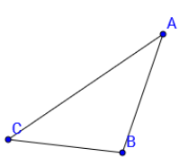
[2nd] Can you copy this triangle?
FIRST, try on your own.
SECOND, discuss this with
someone else.
THIRD, list the steps needed
to copy the triangle and make
your copy.

[3rd] How do you _________ _ To construct a parallelogram, 1st Construct a pair of
parallelogram? parallel lines. 2nd The two parallel lines in your construction
are both intersected by a third line called a ___________.
Construct a fourth line that is parallel to this ___________.
This should make four sides of a parallelogram.

1st Make two intersecting lines, 2nd Construct a line parallel to $\overset{⃡}{BC}$
$\overset{⃡}{AB}$ and $\overset{⃡}{BC}.$ that goes through A.

3rd Construct another line parallel to $\overset{⃡}{AB}$ that passes through C.
This should give you two pairs of parallel lines that make a parallelogram.

[4th] What are skew
lines?

[5th] What are coplanar
points?

[6th] what are noncoplanar
points?

