Geometry Lesson 1-11: Students will use variable expressions to find angle measurements; students will show mastery of various construction techniques.
_____________________________

[1st] Find the next letter L I F C ___
in this pattern:

[2nd] Suppose two angles
have a sum of 180º and the
larger angle is 18º more than
the smaller angle.
Find the measure of each.

[3rd] What strategies can you
use to find both angles?

[4th] m/ A means what?

[5th] m/ Q is twice m/ R.
Together they have a sum of
81º. Find the measure of each.

[6th] What strategy can you
use to find both angles?
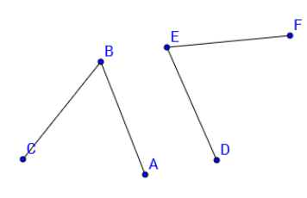

[7th] m/ ABC = what?

[8th] m/ DEF = what?

[9th] Show AND explain how to
use / ABC and / DEF to construct
an angle equal to the measure of
both angles combined.

[10th] Find the measure of each m/ E is five times m/ F, and both have a sum of 78º.
angle:

m/ G is five more than m/ H, and both have a sum of 59º.

m/ J is eight less than m/ K, and both have a sum of 100º.

[11th] m/ W is two-thirds of
m/ Y. If m/ Y = 24º, find
m/ W.

[12th] m/ W is three-fourths of
m/ Y. If m/ W = 33º, find
m/ Y.

