Geometry Lesson 1-2 Objective: Students will take measurements with a ruler, a compass, and a protractor; students will also copy segments and angles.
______________________________________________
[1st] Fill in the missing
letters for this unit D __ G __ __ __
of measure:

GEOMETRY NOTES 1-2: Using a Ruler, Compass and Protractor

$\overline{YZ}$ is $\frac{15}{16}$ inch long. __________________________________
Y Z
_________________________
A B
[2nd] How long is $\overline{AB}$ ? _______________
C D
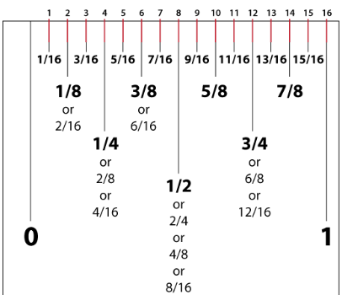
[3rd] How long is $\overline{CD}?$

[4th] How many increments
are there from 0 to 1 inch?
How does this affect the way
we measure with inches?

[5th] With your own ruler,
draw a segment that is
2 $\frac{3}{4}$ inches long.

[6th] With your ruler, draw a
segment that is 1 $\frac{7}{8}$ inches long.

[7th] Use your compass to copy $\overline{AB}$, $\overline{CD}$, and $\overline{YZ}$.

For each segment, center your EXAMPLE: Original Copy
compass at one endpoint and
set the pencil point on the other
endpoint; then transfer that
distance to your own drawing area.
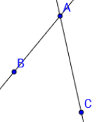
[8th] Copy / BAC: NOTICE that AB < AC.

To do this, first plot a point on your paper. Call it A. (This will be
the vertex of your angle). Second, use your compass to measure
the distance on this sheet from A to B. Copy $\overline{AB}$ onto your paper.
Make $\hat{AB}$ fairly long. Third, with your compass, measure the
Distance from B to line $\overset{⃡}{AC}$. Mark this distance on your drawing.
Label D where the two arcs meet. Then connect A and D.

FIRST SECOND THIRD FOURTH
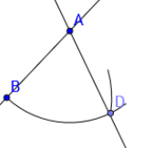
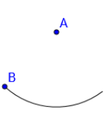
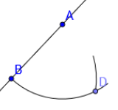

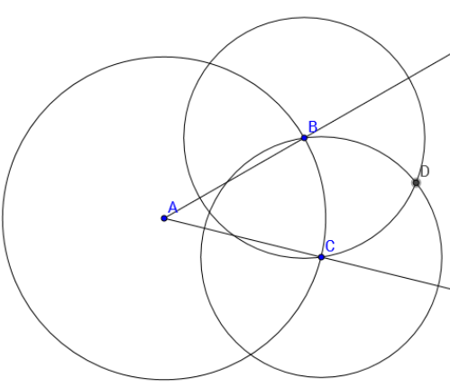
Examine circles A,B, and C.
B and C are on circle A.
C is on circle B and B
is on circle C.
D is on circles B and C.

[9th] Which is closer to A,
B or C? **Explain what
this means for $\overline{AB}$ and $\overline{AC}$.

[10th] Which is closer to D,
B or C? **Explain what this
means if you draw $\overline{BD}$ and $\overline{CD}$.

[11th] If you draw $\vec{AD}$, which angle
will be wider, / BAD or / CAD?

We can use the above construction
to do what with / BAC?

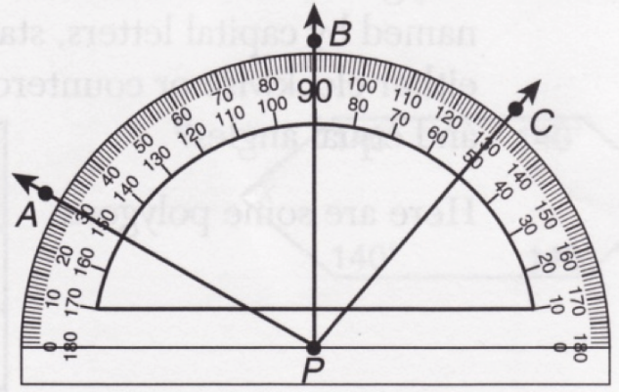
[12th] Find the measure of
each angle in degrees:

/ APB
/ CPB
/ APC

