Geometry Lesson 1-3: Students will construct a perpendicular bisector of a segment, explore parallel lines, and bisect an angle.
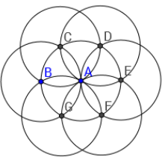
NOTES: Bisecting Angles and Segments
[1st] With your compass, construct
this image:

[2nd] If you connect B to C to D to E
to F to G to B, what shape will you get?
Explain your response.

[3rd] What were important ideas from
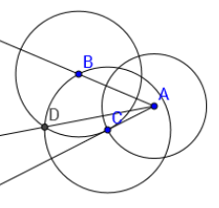
yesterday’s lesson?

[4th] Does $\vec{AD}$ bisect / BAC? Explain
your reasoning.

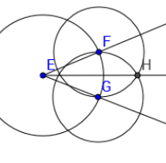
[5th] Does $\vec{EH}$ bisect / FEG? Explain
your reasoning.
(Circles F and G have the same
radius.)

*What must happen for the ray
to bisect the angle?

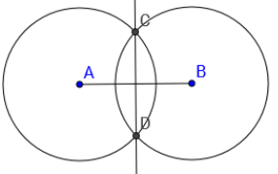
Circles A and B have the same radius.
C and D are on both circles.
[6th] Is C closer to A or B? Explain.

[7th] Is D closer to A or B? Explain.

[8th] What do all points on $\overline{CD}$ have
in common?

[9th] Create your own segment $\overline{AB}$
and construct circles A and B so that
they have the same radius. Then connect
C and D.

[10th] Measure both parts of $\overline{AB}$ and explain
what you notice. Also measure the angles
formed at the intersection of $\overline{AB}$ and $\overline{CD}$.
Explain what you notice.

[11th] $\overline{CD}$ is called the _______ ________ of $\overline{AB}.$

_________________________________
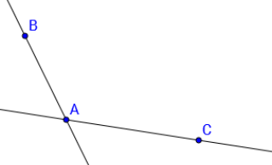
Suppose you could copy and slide
/ BAC so that the copy moved up Before
to have its vertex at B?

[12th] Explain how the higher and lower lines
are related? Explain your reasoning.

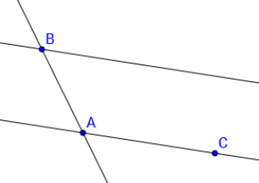
[13th] With your compass and straightedge,
recreate this construction of / BAC and
the copy angle: MAKE SURE your copy
has B as the vertex. After

