Geometry Lesson 1-4: Students will define the following: [a] segment, [b] angle, [c] circle; etc.
They will also review how to copy a segment and an angle, as well as bisect a segment and an angle.
___________________________________________

GEOMETRY NOTES Basic Constructions and Definitions: Page 1-4
Zero, One, and Two Dimensions

[1st] What is A point is an undefined term; it names a specific ____ in
a point? space. It has _______ length, width or _______. For
example, A is a point:
. A

[2nd] What is A line is an undefined term: it is a set of all ______ along
a line? a straight ____, going forever in two __________directions.
A line has ______ length and ____ width and height. For
example, $\overset{⃡}{BC}$ is a line passing through points ___ and ____:

. A
$\overset{⃡}{ B C }$
[3rd] What does NOTE: Any two______ determine a _____. This means any
collinear mean? two points are collinear (are on the same line—EVEN IF
that line is not shown). This means A and B are __________.
Likewise, A and C are __________.

[4th] Noncollinear A, B and C are ______________, because all three do not line
means what? up.

[5th] What is a A ray is the set of all points that start from a given point
ray? and continue forever in ____ direction (Harry Stiles
notwithstanding). A ray has ______ length and no width or
height. For example, $\vec{DE}$ is a ray that starts at ____ and
goes through ____ forever:

$\vec{D E }$

[6th] What is a A segment is a set of all points between two given points. A
segment? segment is _____ in length. For example, $\overline{FG}$ is a segment:

$\overline{F G}$

[7th] What is an An angle is formed by any two rays that have a common
angle? ______. The common _____ is called the ______ of the
angle. For example, / ABC is an angle with vertex ____ (and
this is why ___ is the middle letter for the angle’s name):
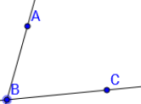

[8th] What is a A circle is the set of all points that are ______ from a
circle? given point called the _____. Circle D is an example:
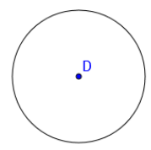

[9th] What is an An arc is a set of points (NOT all possible points) that are
arc? _______ from a given point. $\hat{FG}$ is an example:
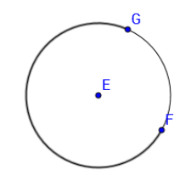

[10th] Solve this equation.
Explain each step. 24 – 5x = 3(4x + 5)

[11th] What is an angle
bisector? Construct an example.

