Geometry Lesson 1-8: Students will construct an equilateral triangle and a regular hexagon; students will also review how to write variable expressions based on written descriptions.
__________________________________________________
GEOMETRY PAGE 1-8
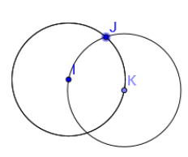
[1st] With your compass, recreate
this construction:

[2nd] If you connect I, J and K,
what type of figure do you get?
Be as specific as possible?

[3rd] Explain how the distances
among I, J and K are related.

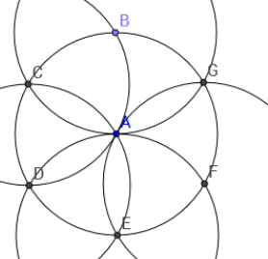
[4th] Recreate this construction:

[5th] If you connect B to C to D to
E to F to G to B, what type of figure
do you get? Be specific.

[6th] Explain how the different
circles in the diagram are related.

[7th] Construct an equilateral triangle.

[8th] Construct a regular hexagon.

[9th] Suppose / A measures aº.
Also suppose / B is 12º smaller than / A.
Write an expression for the measure of
/ B that uses the variable a.

[10th] Angle G is twice the measure of
angle H. If angle H measures nº, write
the measure of angle G in terms of n.

[11th] Two angles have measures with a
sum of 90º. If one of the angles measures
bº, write an expression for the measure of
the other angle.

