Geometry Lesson 1-9: Students will construct a square and a rhombus.
_____________________________________________
GEOMETRY NOTES Special Quadrilaterals Page 1-9

[1st] Can you write 100 using only 9’s?

[2nd] Figure A has four sides, all congruent.
Figure B has four angles, all congruent.
What are the differences between
A and B?

Can A and B be the same figure?

[3rd] Using what you know so far,
can you construct a square?
FIRST THINK BEFORE YOU READ ON.

_____________________________________________

To construct a square, first begin with a ______ angle. To do this,
construct a segment and its _____________ ___________.
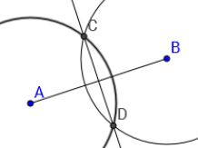

Second, label the midpoint of $\overline{AB}$ : call this point E. Then construct
circle E so that EB = EF. This makes two sides of your square the
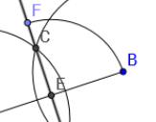
same ________, and they meet at a ______ angle.

Third, construct two more arcs with the same radius as circle E:
center the first arc at __ and the second arc at ___. The point where
these arcs intersect, ___, is the fourth ______ __ ____ ______.

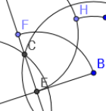
Finally, connect F to H and H to B.

[4th] How do you construct A rhombus is a quadrilateral in which all sides are _________.
a rhombus? 1st Construct a segment $\overline{AB}$. 2nd Use your compass to measure
from A to B; mark off that same ________ from A to a different point.
Label this point C. 3rd Measure this same distance with your compass,
but center the compass at __: mark off this arc. 4th Measure this same
distance, but center your compass at ___: mark off this arc so that it
intersects the arc with center B. 5th Label where the two arcs inter-
sect point D. Connect B to D and D to C.
*NOTE: We call this rhombus ABDC.
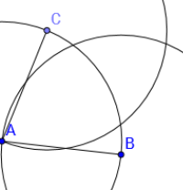
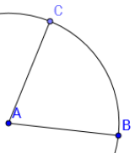

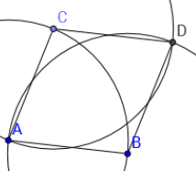

[5th] On binder paper, you need to construct [a] a square, [b] a rhombus.

