Geometry Lesson 2-1: Students will recognize and use the Side-Side-Side Postulate for Triangle Congruence; students will also begin to recognize possible sides for a triangle and use centimeters.
_______________________________________
GEOMETRY NOTES 2-1: Triangles and Congruence

[1st] Can you draw a triangle with
sides that are 1 inch, 2 inches and
4 inches long?

[2nd] How many triangles are
possible that have side lengths
of 1 $\frac{1}{4}$ inches, 2 $\frac{1}{2}$ inches and
3 inches? Try to draw as many
as you can.

[3rd] How many triangles are _____________ ______________________
possible with the given segments? _________________________________________
Use your compass and try to draw
as many as you can.

A ________________________________________ B
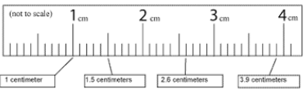

[4th] To the right is an expanded diagram
of a centimeter ruler.

How long is $\overline{AB}$ according to the diagram?
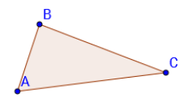
[5th] Suppose you use your compass
and straightedge to copy /\ ABC.
Explain your method and how it
relates to the number of possible
triangles with three given sides.

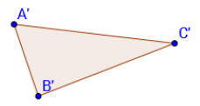

[6th] Compare /\ ABC with /\ A’B’C’.
What do you notice?

[7th] What is the Side-Side-Side
Postulate and what does it mean
for triangles?

[8th] How can you tell whether
three segments can form a
triangle?

C _______________________D
[9th] To the right is an expanded diagram
of a centimeter ruler.

How long is $\overline{CD}$ according to the diagram?

Each centimeter is broken into how many
parts?

(The following is NOT part of the notes: this is a Unit Challenge that will be covered at the end of the unit. Students are welcome to complete this and submit their solutions ahead of schedule for extra credit.)

*UNIT CHALLENGE #1: Allentown, Benwood, Colfax and Deon are four cities all on a straight highway. The distance from Allentown to Benwood is 5 miles; the distance from Benwood to Colfax is 8 miles; the distance from Colfax to Deon is 6 miles. What is the possible distance from Allentown to Deon? JUSTIFY your response step by step.

*UNIT CHALLENGE #2: A major league baseball diamond is a square that is 90 feet on each side. One day a catcher and a third baseman had an argument. The catcher argued that whenever he must throw out a runner stealing from first to second, his throw is farther than that of the third baseman when he throws from third base to first base. The third baseman argued that his throw is as far as that of the catcher. Decide who is correct and justify your response step by step.

