Geometry Lesson 2-2: Students will prove that vertical angles are congruent; they will also recognize the Angle-Side-Angle and Side-Angle-Side Postulates for congruent triangles.
_________________________________________

GEOMETRY NOTES 2-2: Vertical Angle Theorem , Side-Angle-Side Postulate, Angle-Side-Angle Postulate

[1st] This instrument can get you
through the woods or around an arc.

In the diagram, two lines intersect to
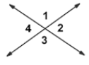
form four angles.

[2nd] If you place a protractor at the
point where both lines intersect,
m/ 1 + m/ 4 = ? .

[3rd] If you place a protractor at the
point where both lines intersect,
m/ 1 + m/ 2 = ? .

[4th] What is greater, m/ 1 + m/ 2 OR Vertical Angle Theorem
m/ 1 + m/ 4?

[5th] Complete the following m/ 1 + m/ 2 = _______ because ____________________
justification (proof):
_________________________________________________.

m/ 1 + m/ 4 = _________ because_____________________

__________________________________________________.

m/ 1 + m/ 2 = m/ 1 + m/ 4 because ________________

__________________________________________________.

If you subtract m/ 1 from both sides of the equation, then

_____________. Therefore, __________________________.

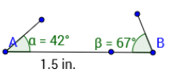
[6th] Suppose you have a triangle:
You are given one side is 1 $\frac{1}{2}$ inches
and it is surrounded by a 42º angle
and a 67º angle.
*HOW MANY TRIANGLES ARE
POSSIBLE with these conditions?
Try to draw as many different
triangles as you can.

[7th] Suppose you have a triangle
and you are given one side length
and the two surrounding angles.
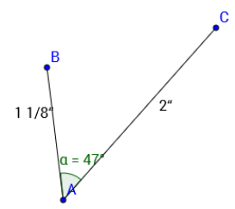
HOW MANY TRIANGLES ARE POSSIBLE?

Now look at a different situation.
[8th] Suppose you are given two sides
are, say, 1 $\frac{1}{8}$ inches and 2 inches, AND
the included angle (between them)
is 47º. HOW MANY TRIANGLES ARE
POSSIBLE with these conditions?

[9th] Suppose the two given sides
are 2.5 inches and 4.25 inches, and
suppose the angle between them
is 19º. How many triangles with these
features are possible?

[10th] What is the Angle-Side-Angle
Postulate?

[11th] What is the Side-Angle-Side
Postulate?

[12th] REVIEW: What is the
Side-Side-Side Postulate?

