Geometry Lesson 2-3: Students will recognize which conditions guarantee, and which do not guarantee, congruence for two triangles.
___________________________

[1st] A refrigerator is regularly
changing temperature. After the
temperature goes up 3º, down 7º,
and up 6º, it is 51º. What was
the temperature before these
three changes?

[2nd] Suppose three segments
are 0.75 inches, 1.5 inches, and
1.5 inches long.
How many different triangles
are possible with these conditions?
What type of triangle is this?
*JUSTIFY your responses.

[3rd] Next, suppose you have
two given segments measuring
1 $\frac{3}{4}$ inches and 1 $\frac{1}{2}$ inches, and they
include (which means surround) an
angle of 50º. How many different
triangles are possible with these
conditions? JUSTIFY your response.

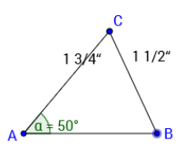
[4th] Now suppose you have
two given segments measuring
1 $\frac{3}{4}$ inches and 1 $\frac{1}{2}$ inches, and they
do NOT include a 50º angle; see
the diagram at the right. A non-
included angle must be 50º.
HOW MANY DIFFERENT TRIANGLES
ARE POSSIBLE WITH THESE CONDITIONS?

[5th] So far we have three working
postulates for triangle congruence:

[6th] ____ _____ ______ is NOT a valid
postulate: WHY?

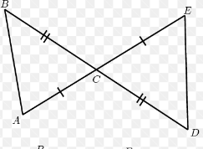
[7th] Examine each pair of triangles.
Determine which pairs are congruent.
Justify your responses.

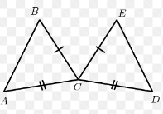

[8th] What must be true so that
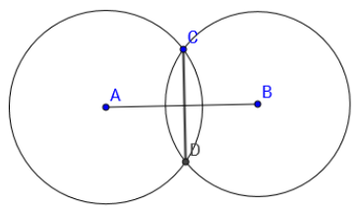
$\overline{CD}$ is the perpendicular bisector
of $\overline{AB}$?

