Geometry U 1-10: Copying Polygons Put all work and responses on another paper.
The verb “construct” means to use a compass and a straightedge.

1] Construct a parallelogram. MAKE SURE the sides are NOT parallel with any blue lines on your paper: otherwise, you will appear to make your drawing by eye, not by instruments.

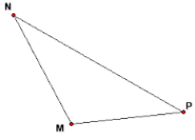
2] Construct a copy of /\ MNP:

3] Record the measure of each angle in /\ MNP.

4] Copy / M; then construct the angle bisector of / M
on your paper.

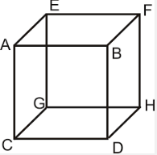
5] Are A, D, and G coplanar points? Explain your response.
6] Are A, B, C and G coplanar points? Explain your response.

7] Explain how $\overset{⃡}{AE}$ and $\overset{⃡}{BD}$ are related.

8] Are C and F collinear points? Explain your response.

9] Challenge: Explain step by step how to construct
a regular polygon with 12 sides (called a dodecagon).
Also construct an example.

