Geometry U 1-11 Angle Logic Put all work and responses on another paper.

1] Two angles have measures that add up to 72º. One angle is three times as large as the other.
Find the measure of both angles.

2] m/ A is 12º smaller than m/ B. The sum of both angles is 39º. Find the measure of both angles.

3] m/ P is three-fifths of m/ Q. [a] Suppose m/ Q = 15º. Find m/ P. [b] Suppose m/ P = 15º. Find m/ Q.

4] Construct each of the following: [a] a regular hexagon [b] a parallelogram

5] Draw segment $\overline{GK}$ so that it is 2 ½ inches long. THEN construct the perpendicular bisector of $\overline{GK}$.

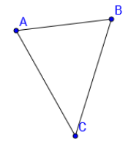
6] Construct a copy of /\ ABC.

7] REVIEW your NOTES.

