Geometry U 1-1 Can You Draw These? Put all work and responses on another paper.

Try to draw each of the following designs by using a pencil, a ruler, a compass, and any other tool you might have. Do not simply trace each design.

1] 2]
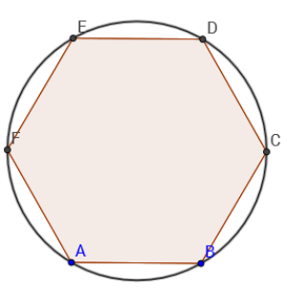
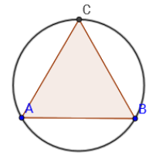

3] 4] *Challenge
