Geometry U 1-2 Welcome to Measurement Put all work and responses on another sheet.
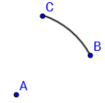
1] On your paper, plot
a point. Call it A.
Next, center your compass
at A and draw a set of points
that form an arc. (such as $\hat{BC}$—see the example.)

*Explain what all the points on $\hat{BC}$ have in common.
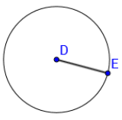
2] On your paper, plot a point. Call it D.
Next, center your compass at D and set
the radius to 1 ¼ inches.
DE = 1 ¼ “. (Go half way between DE = 1 ¼ “
1 inch and 1 ½ inches.) **This circle is too small.
Make yours the correct size.
**Explain what all the points on circle D have in common.

3] Use your compass to measure $\overline{FG}$ (segment FG).
To do this, put the point of your compass on F and
the pencil point on G.
Next, ON YOUR PAPER, plot a point. Call it F.
Then center your compass—set to the length of $\overline{FG}$—
on point F on your paper and mark off the length of $\overline{FG}$on your paper.
Finally, on your paper, connect F to the compass marking, so that you have a copy segment of $\overline{FG}$.

*Is your copy of $\overline{FG}$ the same length as the original on the worksheet? Explain what measurement tool you used, to guarantee both are the same length.

4] Use your compass to copy each segment below on your paper:

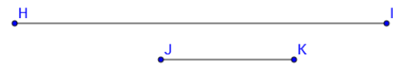

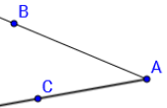
5] Use your ruler and find HI and JK (the length of each segment in problem 4). Find each length to the nearest $\frac{1}{16}$ of an inch.

6] Use your protractor and find the measure, in degrees,
of / ABC. Also name the vertex of the angle.
7] On your paper, make a copy of / EDF. original angle
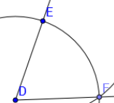
To do this, first plot a point on your paper.
Call it D. (This will be the vertex of your angle).
Second, use your compass to measure the distance
on this worksheet from D to $\hat{EF}$. Copy $\hat{EF}$ onto
your paper. *Make sure the distance from D to E
is the same as the distance from D to F.
Third, with your compass, measure the distance
EF on this sheet: copy that distance onto your paper.

Your copy should progress this way:

1st 2nd 3rd
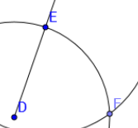
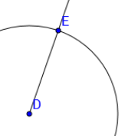

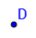

Finally, connect D and F.

8] Measure each angle below to the nearest degree:

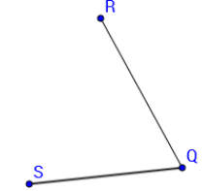
[a] [b]
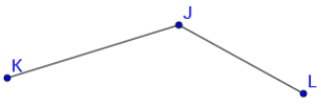

9] REVIEW your NOTES.
If you don’t review your notes, you can’t have any pudding. How can you have any pudding if you don’t review your notes?

