Geometry U 1-3, Bisect Segments and Angles Put all work and responses on another sheet.
The verb “construct” means to use a compass and straightedge for your constructions.

1] Use your compass to create an acute angle.
Then bisect that angle. (See the example.)

First Second Third Fourth
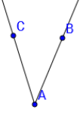
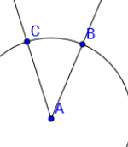
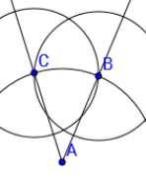
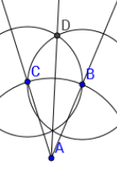
*B and C must be equidistant from A.

2] Construct a segment. Then construct the perpendicular bisector of that segment. (See the example.)

First Second Third
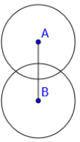
*Circles A and B must have the same radius, so that C and D are equidistant from both A and B.
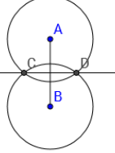
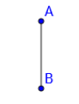

3] Construct an obtuse angle. Then construct the bisector of that angle.

4] On your paper draw a line. Label two points on the line A and B. Next, plot a point NOT on the line and label it C. Third, connect A and C to make / CAB.
*Copy / CAB so that your copy angle has its vertex at C, and so that you have created a line through C that is parallel with $\overset{⃡}{AB}$. (See the example on the next page.)

4] (Example)
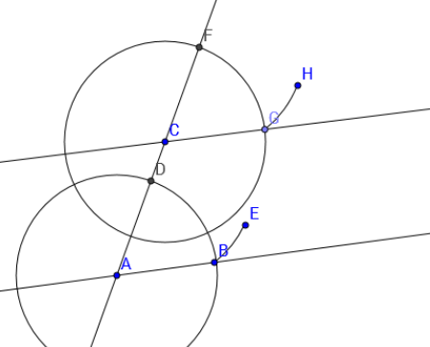
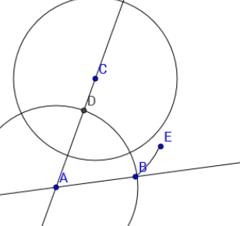
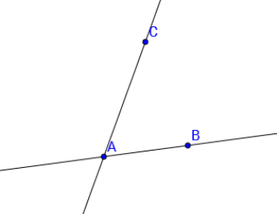
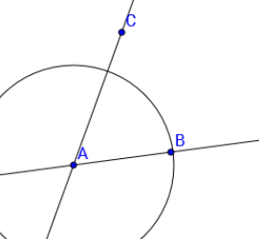
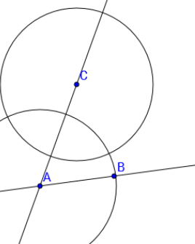

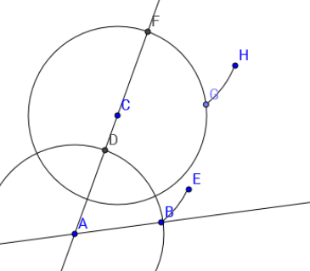

5] [a] Use your straightedge and protractor to draw a 65º angle.
[b] Use your protractor to draw a 115º angle.
[c] If both angles share a vertex and an edge, so that together they form a larger angle, what type of angle will this larger angle be?

6] Find $\overline{QR}$ in inches: Q R
_____________________________________________________

7] REVIEW your NOTES.

