Geometry U 1-4: Total Recall Put all work and responses on another sheet.
You should use your notes as your guide.
1] With your ruler, measure $\overline{AB}$ in inches.

2] Construct a copy of $\overline{AB}$. Show your arc mark.

3] Construct the perpendicular bisector
of your copy of $\overline{AB}$. Show your arc marks.

4] With your protractor, measure / CDF
in degrees.

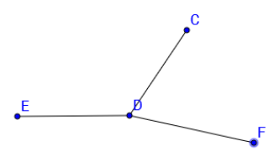
5] Construct a copy of / CDF.
Show your arc marks.

6] Bisect your copy of / CDF. Show your arc marks.

7] With your protractor, measure / EDF
in degrees.

8] Construct a copy of / EDF.
Show your arc marks.

9] Explain the difference between a line and a segment.

