Geometry U 1-5: Investigation of Distance and Bisection Put all responses on another paper. *The verbs “construct” and “reconstruct” mean to use a compass and a straightedge.
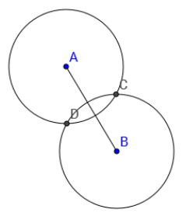
1] Circles A and B have the same radius.

[a] With your compass and straightedge,
reconstruct the diagram of circles A and B.
MAKE SURE both circles have the same radius.
Label C and D where the circles intersect.

[b] Next, connect C and D.

[c] Is C equidistant from A and B? Explain how you know.

[D] Is D equidistant from A and B? Explain how you know.

[e] Choose three random points on $\overline{CD}$ . Measure the distance each point is from C AND from D. Record each distance.

[f] Is each point closer to C or to D?

[g] Label E the point of intersection for $\overline{CD}$ and $\overline{AB}$. *Measure / AEC and / BEC. Record your results.

[h] Explain how $\overline{CD}$ is related to $\overline{AB}$: $\overline{CD}$ is the ________ ___________ of $\overline{AB}$ because ____________
______________________________________________________.

2] / FEG is shown. F and G are both on circle E.
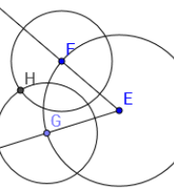
Circles F and G have the same radius. H is on
circles F and G.

[a] With your compass and straightedge,
reconstruct / FEG with circles E, F and G.
MAKE SURE circles F and G are congruent.
[b] Is E equidistant from F and G? Explain.

[c] Is H equidistant from F and G? Explain.

[d] Connect E and H and extend past H to
create $\vec{EH}$.

2] [e] Choose three random points on $\vec{EH}$ and measure how far each point is from F AND from G. Record your results.

[f] Is each point on $\vec{EH}$ closer to F or to G?

[g] Explain how $\vec{EH}$ is related to / FEG: $\vec{EH}$ is the _______ ____________ of / FEG because ________
________________________________________________________________________.

3] Examine the construction to the right. Use it to answer the questions below.
IJ < IK and JL < KL.
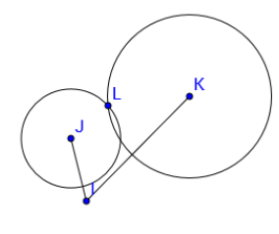
[a] Does I appear to be equidistant from J and K? If not, I is closer to which point? Explain how you know.

[b] Does L appear to be equidistant from J and K?
If not, L is closer to which point? Explain how you know.
[c] If you connect I and L, will points on $\overline{IL}$ be equidistant from J and K? Explain.

[d] If you draw $\vec{IL}$, will it be the angle bisector of
/ JIK? Explain your response.

4] Suppose $\overset{⃡}{PQ }$ intersects $\overline{RS}$. *What conditions must be met, so that $\overset{⃡}{PQ}$ is the perpendicular bisector of $\overline{RS}$?

5] Suppose $\vec{YW}$ is a ray between $\vec{YX}$ and $\vec{YZ}$. All three rays have endpoint Y. *What conditions must be met, so that $\vec{YW}$ is the angle bisector of / XYZ?

6] *Challenge: /\ QRS has the following side lengths: QR = 2 ¾ “, RS = 4 “, QS = 5 “. Can you draw the triangle and find the point equidistant from Q, R and S?

