Geometry U 1-7: Mid-Unit Assessment Put all responses ON THIS SHEET.
Use a compass and straightedge for all constructions. The verb “construct” means to use a compass and a straightedge. SHOW ALL ARCS. You may use your notes.
Put your copy here.
[1] Construct a copy of
$\overline{QR}$. ________________________
Q R

Put your copy here.
[2] Construct a copy of
/ EFG.
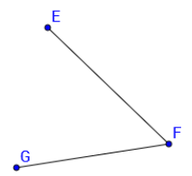

[3] Write a definition for “circle.” ______________________________________________

______________________________________________

______________________________________________

[4] Construct the perpendicular
bisector of $\overline{AB}$.

__________________________
A B

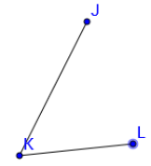
[5] Construct the angle bisector
of / JKL.

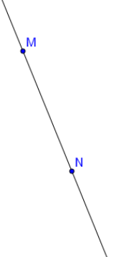
[6] Construct a line parallel
to $\overset{⃡}{MN}$.

[7] Is either $\overline{AD}$ or $\vec{GJ}$ an angle bisector? Explain your reasoning. ______________________________








