Geometry U 1-8: Regular Figures Put all work and responses on another sheet.

1] Construct a regular hexagon in which each side is 4 cm long.

2] Construct an equilateral triangle in which each side is 1 ½ inches long.

3] [a] Copy this angle. Then bisect your copy.
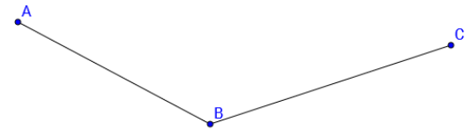

[b] Explain how you know your bisector bisects your copy of / ABC.

4] [a] Draw a segment. Then construct a line that is perpendicular to your segment.
[b] In your construction, did you make a right angle?

5] Draw three collinear points.

6] Explain the difference between an arc and a circle.

7 [a] Are H and I collinear? Why or why not? . G
[b] Are G and I collinear? Why or why not? . H
[c] Are G, H and I collinear? Why or why not?
[d] On your paper, redraw G, H and I so that they are collinear. I .

8] [a] Draw an example of $\vec{QR}$.
[b] Draw an example of $\vec{RQ}$.

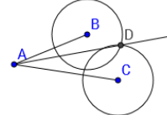
[9] Does $\vec{AD}$ bisect / CAB?
Explain your reasoning.

