Geometry U 1-9: Constructing Quadrilaterals Put all responses on another paper.

1] What is a rhombus? Write a definition AND construct a rhombus; make it without right angles.

2] An architect needs to draw a diagram of a square patio. What should the architect construct first, in order to construct a square on paper?

3] Construct a square and explain your method.

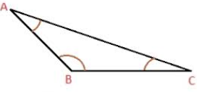
4] Find the measure of each angle;
use a protractor.

M N
5] Find the length of each segment in inches: [a] ____________________________________

[b] Q R
__________________________________________________________

6] Construct an equilateral triangle. *ALSO explain each step of your process.

7] REVIEW your NOTES.

