Geometry U 2-1 Three Sides for the Triangle Put all work and responses on another paper.

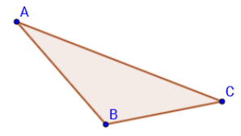
1] [a] Construct a copy of this triangle on
your paper.

[b] Is it possible for someone else to copy
the three sides of this triangle but end up
with a different shape? Explain your response.

2] Suppose you have three segments that are
18 inches, 27 inches, and 3 inches long.

[a] How many triangles are possible with these three segments as sides?
JUSTIFY your response.

[b] Draw as many different triangles as you can with these three segments for sides.

3] Suppose you have three segments that are
2$\frac{3}{4}$ inches, 2 inches, and 3 inches long.

[a] How many triangles are possible with these three segments as sides?
JUSTIFY your response.

[b] Draw as many different triangles as you can with these three segments for sides.

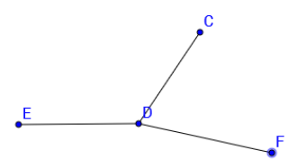
4] With your protractor, measure / CDF
in degrees.

5] Construct a copy of / CDF.
Show your arc marks.

6] Bisect your copy of / CDF. Show your arc marks.

7] Explain in words what the Side-Side-Side
Postulate means.

