Geometry U 2-2 Triangle Congruence Put all work and solutions on another sheet.

1] Draw an example of two triangles which are congruent by the Angle-Side-Angle Postulate.
MAKE SURE to mark congruent parts.
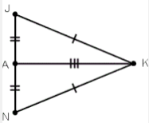
2] Are /\ JAK and /\ NAK congruent?
If so, by what argument?

3] Copy and complete the following justification:
[a] JK = ? ; this is given.
[b] JA = ?; this is given.
[c] ? = AK; a segment equals itself in length.
[d] /\ JAK $\tilde{=}$ ? by the _______ Postulate.

4] [a] How many triangles are possible
with the following conditions?
Two segments are 2.5 inches and 1.75 inches
long, and they surround a 36º angle.

[b] Do these conditions go with a postulate for triangle congruence? If so, what postulate?

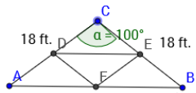
5] Two trusses for the attic of a house are shown at the right.
AC, BC, A₁C₁, and B₁C₁ are each 18 feet long. / C and / C₁ each measure 100º.

[a] Are /\ ABC and /\ A₁B₁C₁ congruent? If so,
by what postulate?
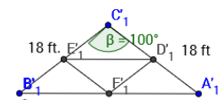
[b] If both trusses must go in the same attic,
how important is their congruence? Justify
your response.

6] Copy and complete the following proof:
[a] AC = ? because each is ? long.
[b] ? = B₁C₁ because ____________.
[c] / C $\tilde{=}$ / ? because ____________.
[d] /\ ABC $\tilde{=}$ /\ A₁B₁C₁ by the ___________ Postulate.

7] Construct a right angle. Show your arcs.

