Geometry U 2-3 Conditions for Congruence Put all work and responses on another paper.

1] Say whether each pair of triangles is congruent. If a pair is congruent, name the postulate that guarantees the congruence.
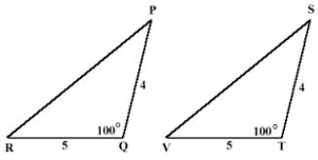
[a] [b]
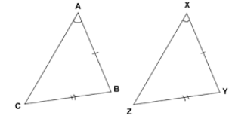

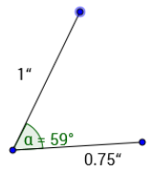
2] [a] How many triangles are possible, given two sides are
1 inch and 0.75 inches and they include a 59º angle?

[b] Is this an example of a congruence postulate? If so,
which one? Justify your response.

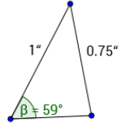
3] [a] How many triangles are possible, given two sides are
1 inch and 0.75 inches and a 59º angle is adjacent to
the 1-inch side but not the 0.75-inch side?

[b] Is this an example of a congruence postulate? If so,
which one? Justify your response.

4] [a] How many triangles are possible with ________________________________
these three segments? __________________________
______________________________
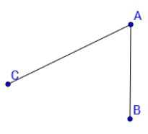
[b] Copy these three segments to form
a triangle. List the length of each side.

5] Copy / BAC; then construct its
perpendicular bisector.

6] Find the measure of / BAC.

7] Construct a regular hexagon.

8] / Q is 1.5 times the measure of / R. [a] Suppose m/ R = 28º; find m/ Q.

[b] Suppose m/ Q = 36º; find m/ R.

9] *Challenge: Draw an obtuse triangle; then construct the perpendicular bisectors of all three sides.
*Explain what you notice: be specific.

