Geometry UNIT 2 Check-off List of Understanding
For each item below, check off the item when you know you are able to do it.
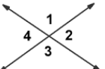
1] Justify the fact that angles 1 and 3
are congruent.

2] $\overset{⃡}{QR}$ | $\overline{MP}$. [a] Explain in words what this statement says AND what it means. Be specific about every item. [b] Justify the fact that any point on $\overset{⃡}{QR}$ is equidistant from M and P. INCLUDE a DIAGRAM.

3] In the diagram at the right, lines m and n are each intersected
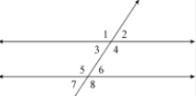
by a third line. COMPLETE EACH STATEMENT.
[a] / 1 and ? are alternate ? angles. m

[b] / 5 and ? are alternate ? angles. n

[c] / 4 and / 6 are ? ? ? angles.

[d] What conditions must be met, so that m || n?

[e] Suppose m || n. Justify the fact that / 3 $\tilde{=}$ / 6.

4] The sum of the angles in any triangle is equal to a certain integer. Justify this fact and name the integer.
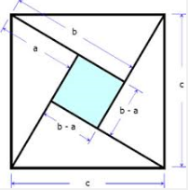
5] Use the diagram at the right to
write a justification for the Pythagorean
Theorem.

6] Which of the following guarantee that two triangles are congruent?

[a] Angle-Side-Angle [b] Angle-Angle-Side [c] Side-Side-Angle

7] Say whether each pair of triangles is congruent. If a pair is congruent, name the postulate or theorem that guarantees congruence.

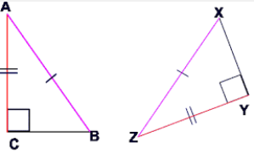
[a] [b] [c]
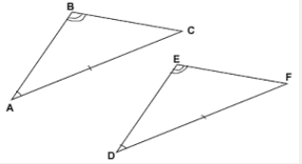
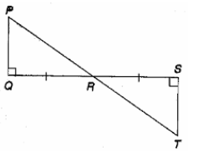
8] Justify the fact that the base angles of an isosceles triangle must be congruent.
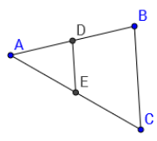
9] In /\ ABC, D is the midpoint of $\overline{AB}$ and E is the midpoint of $\overline{AC}.$
What is the relationship between $\overline{DE}$ and $\overline{BC}$?

10] What special properties exist for a parallelogram? List as many properties as you can.

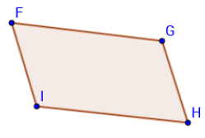
11] Suppose FGHI is a parallelogram.
Justify the following: [a] Opposite sides are congruent.
[b] Opposite angles are congruent.

