Features of Functions

For this unit you are expected to master the following concepts:

[1.1] know and use the definition of a function; recognize and use function notation;
[1.2] name the domain and range of a function;
[1.3] read and interpret the graph of a function;
[1.4] name and explain increasing and decreasing behaviors of functions;
[1.5] name and explain the intercepts of a function;
[1.6] name and explain the end behaviors of a function;
[1.7] name any extrema (minima or maxima) for a function;
[1.8] given a value for x, find f(x); given a value for f(x), find x.

Here are sample questions for this unit. This is not a full, comprehensive set of problems.

[1] Name the domain and range for f(x), which f(x)
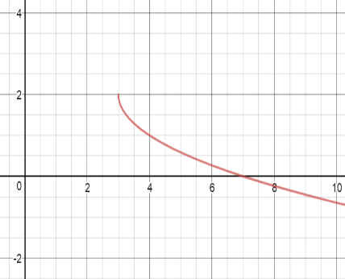
is graphed to the right:

[2] Is f(20) greater than, equal to, or less than f(10)? Explain your response.

[3] Name any minima or maxima for f(x).

[4] Examine the graph of g(x): identify where g(x) is g(x)
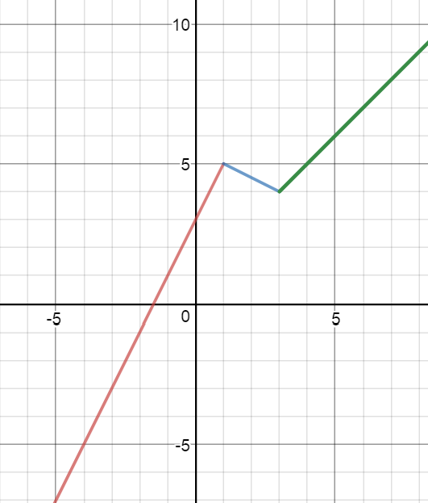
increasing and where it is decreasing.

[5] Name the domain and range of g(x).

[6] Name the x- and y-intercepts of g(x).

[7] For g(x), suppose x represents time in minutes
and g(x) represents the temperature of a storage unit.
Name the time that corresponds with a temperature of
0.

[8] Name any minima or maxima for g(x).

[9] Given that h(x) = 2x – 5, find h(-1).

[10] Given that j(x) = $\sqrt{4+3x}$ , find x when j(x) = 1.

Some people learn these skills because they are told to learn them; some people wonder why they have to know them. Go ahead and wonder—but if you want to succeed, figure it out.

Lesson 1.1 Functions and Function Notation

What is a function? A function is a special relationship between input values and related output values. For example, the outdoor temperature in your backyard is a function of time:

Let t = time in hours past midnight, and let f(t) = the temperature in degrees Fahrenheit at t.
When t time = 7 | 8 | 9 | 10 | What makes this a function is that for each time t,
then f(t) temp. = 68 | 72 | 77 | 81 | there is only one temperature f(t).

**Here’s the important point: For f(t) to be a function, then for each t value, there is ONLY ONE f(t) value; for any function where y = f(x), for EACH input x, there is ONLY ONE output y.

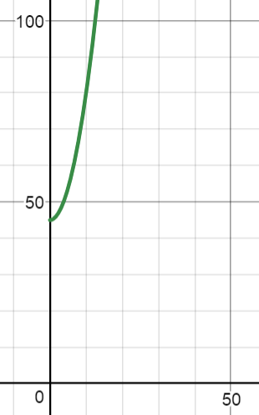
f(t) is a function and its graph shows it is a function: no two points of the graph have the same x value. The graph of f(t) passes the vertical line test: wherever you draw a vertical line, the line will intersect f(t) at only one point.

If you wonder what f(t) means, it means “the function of t”: it does not mean multiply f by t. When you read f(x) = x² – 5x, you should say, “The function of x equals x squared minus five x.”

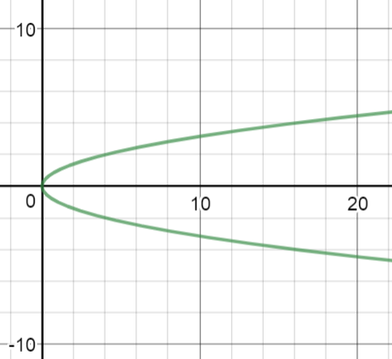
The relation R that is graphed below f(t) is NOT a function. Notice the graph of R does not pass the vertical line test: if you draw a random vertical line that intersects the graph, the line will touch more than one point.

SAMPLE QUESTIONS
Now it’s your turn: you should see if you can answer these sample questions.

Determine which of the following relations are functions. In each case, explain your thinking.

[1] [2] (-2, 3), (-2, 2), (-1, 1), (0, 0), (1, 1)
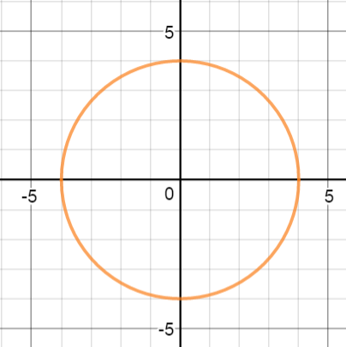

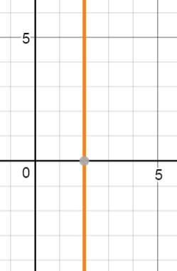
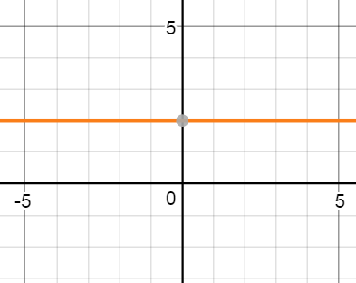
[3] [4]

Lesson 1.2 Domain and Range of a Function

The domain of a function is the set of all input values (in many cases, the set of all x values) that you can plug into a function, in order to find a function value.

The range of a function is the set of all output values (in many cases, the set of all y values) you can get for a function.

You will be asked to name the domain and range for a given function.

EXAMPLE 1.2 A Name the domain and range for f(x) = $\sqrt{x-3}+5$.

Solution: To name the domain for f(x), you need to realize that you cannot take the square root of any number below zero. Therefore you need to set the radicand x – 3 > 0 and solve for x: If x – 3 > 0, then x > -3. Your domain is such that x must be -3 or greater. This is your domain. In set notation, we say {x| x > -3}; in interval notation we say [-3, $∞$). The square bracket tells you -3 is included, while the parenthesis tells you infinity is not included.

The range of f(x) can be identified by realizing that, since the lowest value possible for $\sqrt{x-3}$ is zero, the lowest value for $\sqrt{x-3}+5$ is 5. f(x) can go higher than 5: it just cannot go below 5. Therefore, for the range we say this: y > 5. In set notation, we say {y| y > 5}; in interval notation we say [5, $∞$).

EXAMPLE 1.2 B Name the domain and range for g(t), g(t)
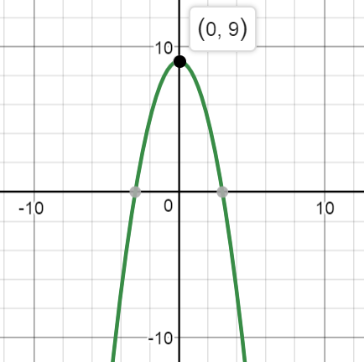
which is graphed at the right.

Solution: If you look closely, the graph goes left and right without end: we can’t graph the entire function; it continues beyond the page. Therefore the domain is ($-∞,∞$), the set of all real numbers.

The graph is limited in how high it goes: the highest g(t) value is 9. Therefore the range is [9, $∞$), the set of all numbers 9 and above.

SAMPLE QUESTIONS
Try these questions. For each function, name the domain and range.

[5] y = x² – 6. [6] [7] f(x) = $\sqrt{2x+1}$
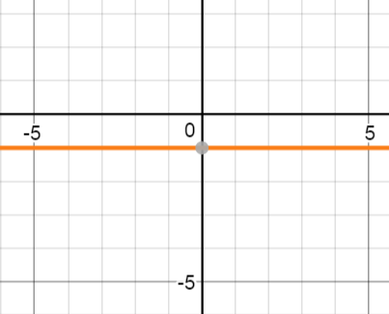

Lesson 1.3 Reading and Interpreting Graphs of Functions

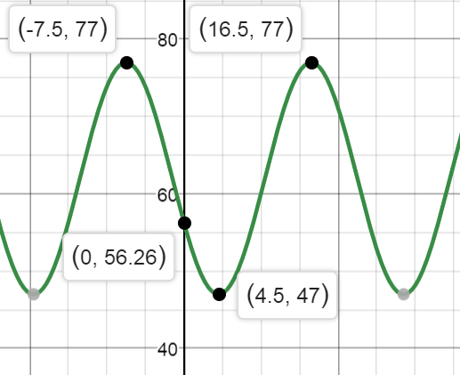
To the right is the graph of a function that
relates the time of day t to the temperature h(t), in a controlled environment.
Let t represent time in hours, t = 0 represent the time at midnight on March 4, and let h(t) represent the temperature at time t.

You can use the graph to tell you several things:

*At time t = 0 (midnight, March 4), the temperature h(0) = 56.26º. -10 0 10 20

*h(4.5) = 47. We say, “h of 4.5 equals 47.” In real English, at 4:30 a.m., the temperature is 47º.

*If you need to state the temperature at t = 10 (10 hours after midnight), you can estimate this. The x-axis is scaled with five-hour increments, so at t = 10, h(10) appears to be about 60, so at 10:00 a.m., the temperature is about 60º.

*You can see that the graph shows a minimum temperature of 47º and a maximum temperature of 77º.

*The function is periodic: it repeatedly goes up and down. This is a trigonometric function.

*If you look at the change in time t from high point to the next high point, you will see that $∆t$—the change in t—is 24 hours. We can use this change to say that every 24 hours, the temperature returns to what it was in this controlled environment. This means that when t = 24, the temperature will be 56.26º, the same as at t = 0.

SAMPLE QUESTIONS
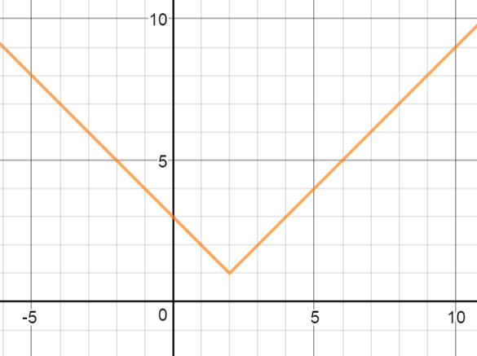
Use the graph of y = g(x)at the right to answer the following questions.

[8] Find g(-1). [9] Find g(5).

[10] Find x when g(x) = 3.

[11] Find the change in y (called $∆y,$ “delta y”) from x = 0 to x = 2.

[12] Is g(-10) greater than, equal to, or less than g(-5)? Explain your thinking.

Lesson 1.4 Increasing and Decreasing Behavior of a Function

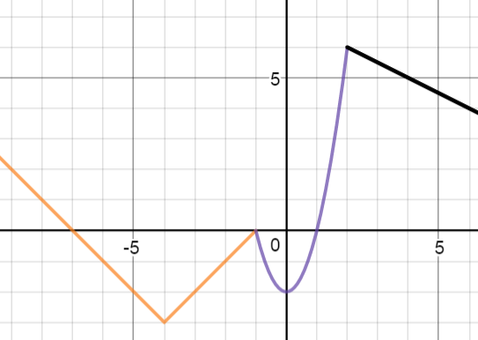
Look at the graph of the function f(x) to the right. Assume that the domain of f(x) is $(-∞,∞)$, the set of all real numbers. Also assume that all trends for f(x) are shown: f(x) continues to climb as x becomes more negative beyond -5, and f(x) continues to fall as x becomes more positive beyond 5.

Read the graph as a book from left to right; in fact, imagine you start at the left and ride the graph as though it is a roller coaster. The roller coaster decreases from the far left until x = -4. Then the roller coaster increases from x = - 4 until x = -1. The roller coaster decreases again until x = 0; then the roller coaster increases from x = 0 to x = 2. Finally, the roller coaster decreases from x = 2 onward, as x approaches infinity.

These intervals of increase and decrease are important in understanding a function. Here, f(x) increases in the intervals $(-4, -1)$ and (0, 2); the function decreases in the intervals $(-∞,-4)$, (-1, 0) and $(2,∞)$.

You should notice that you are to name the intervals on the x-axis where the function increases and decreases.

Graph the function g(x) = -|x + 1| and look at the intervals of increase and decrease.

When x = -3 -2 -1 0 1 2
then y = -2 -1 0 -1 -2 -3

The more of the function that you graph, the more you will see that g(x) increases in the interval $(-∞,-1)$, where $-∞$ < x < -1 . g(x) decreases in the interval $(-1,∞)$, where
-1 < x < $∞$.

SAMPLE QUESTIONS

[13] Identify intervals of increase and decrease for y = x² – 4.
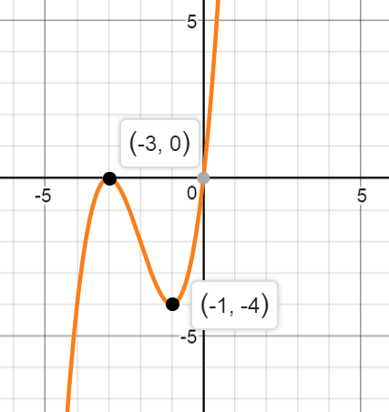
[14] Identify intervals of increase and decrease for h(x), which is graphed at the right.

Lesson 1.5 Intercepts of Functions

Intercepts of functions are significant in many real-life situations. For example, look at the function a(t) = -90,000 + 600t. This function represents the balance in Saria’s account with Deutche Bank. Saria took out a loan to start her own bistro. She owes the bank $90,000 and has agreed to pay the bank $600 a month. For this function, t = time in months after she borrows the money and a(t) = the balance of her account (the amount she owes).
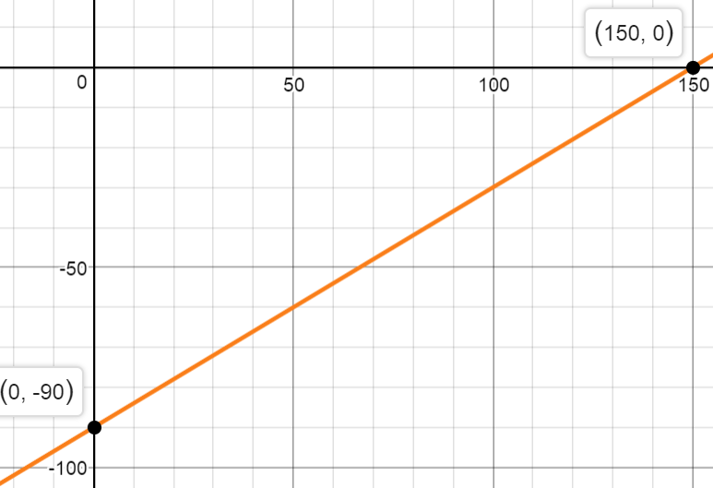
The y-intercept (0, -90,000) represents where Saria’s loan starts, at -$90,000. The x-intercept (150, 0) represents where her loan ends: she will have paid off the entire loan in 150 months.

Notice that the x-intercept is where y = 0 and the
y-intercept is where x = 0. You should know to
substitute 0 for x to find the y-intercept and vice
versa.

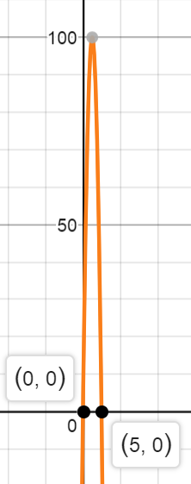
Here is another example: let h(t) = -16t² + 80t. Here the function represents the height of a toy rocket that is launched from the ground with a starting blast of 80 feet per second into the air; while the blast sends the rocket up, gravity pulls the rocket down at an acceleration of 16 feet per second squared. t = time in seconds and h(t) = height in feet.

The t-intercepts of this function show you when the rocket starts rising and stops falling. The rocket begins at t = 0; the rocket falls back to the ground at t = 5 seconds.

Notice the difference between the abstract function
y = -16x² + 80x and the actual function h(t) = -16t² + 80t that fits the real-life rocket. The abstract function for y has the domain of all real numbers, while the real-life function for the rocket has the domain [0, 5], because the rocket starts rising at t = 0 and stops at t = 5.

SAMPLE QUESTION

[15] Find the x-intercept and the y-intercept for the function 20x + 10y = 60, in which x represents the number of adults who attend a concert and y represents the number of children under 12 who attend the concert. Explain what each intercept represents; also explain your reasoning.

Lesson 1.6 End Behavior of a Function

To determine the end behavior of a function, you need to notice overall trends—you need to note what y does as x approaches specific values. While every function has its own end behaviors, certain types of functions have behaviors in common.

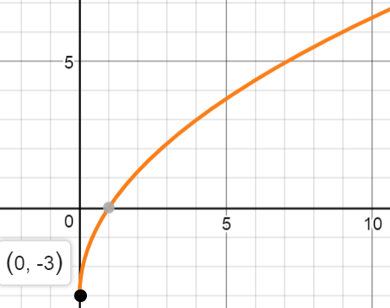
EXAMPLE 1.6 A

To the right is the graph of y = $\sqrt{9x}$ – 3. You can see one endpoint of the function: (0, -3). However, there is no other endpoint: y continues to increase as x increases. The higher the x value that you plug in, the higher the y value you get out. For this reason, we say that as x$∞$, y$∞$. Eventually you will be expected to use a limit to express this end behavior:
The limit, as x approaches infinity, is that y approaches infinity.
$\lim_{x→∞}{\sqrt{9x}}-3$ = $∞$.

EXAMPLE 1.6 B

To the right is the graph of the function f(x) = $\frac{1}{x}$.

Here f(x) is a rational function, a fractional one. IT IS VERY IMPORTANT THAT YOU GET THIS BASIC CONCEPT: DIVIDING BY ZERO IS MEANINGLESS GOBBLEDYGOOK. Because you cannot divide by zero, x cannot equal zero.
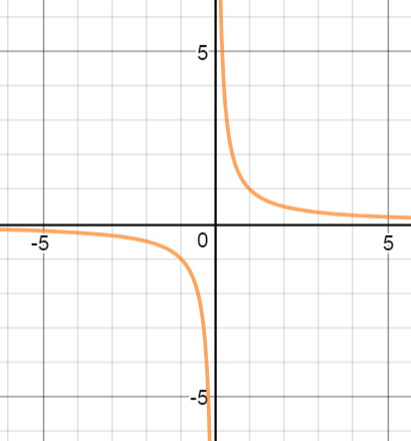
At the right is the graph of f(x). There are four end behaviors we need to name.
[a] As x $-∞$, y $0$: this means that as x approaches $-∞$, y approaches $0$. Notice that as x goes farther left, y gets closer to zero high.
[b] As x $0^{-}$, y $-∞$: this means that as x approaches $0$ from the left, y approaches $-∞$. Notice that as x goes from $-∞$ to 0, y goes farther DOWN without bound.
[c] As x $0^{+}$, y $∞$: this means that as x approaches $0$ from the right, y approaches $∞$. Notice that as x goes from $∞$ to 0, y goes farther UP without bound.
[d] As x $∞$, y $0$: this means that as x approaches $∞$, y approaches $0$.

SAMPLE QUESTION

[16] Name the end behavior of the function graphed at the right.

Lesson 1.7 Extrema (Minima and Maxima) of a Function

A minimum is the lowest y value for a function on a given interval for x. A relative minimum (the same as a local minimum) is the lowest y value for a specific section of a function’s graph—as long as it is not an endpoint. An absolute minimum (the same as a global minimum) is the lowest value of all for a function. Minimum is singular (for one); minima is plural (for more than one).

A maximum is the highest value for a function, for a particular section of the graph or the entire graph. A maximum may be relative or absolute. Maximum is singular, while maxima is plural.

High and low function values together are known as extrema. Extremum is singular; extrema is plural.
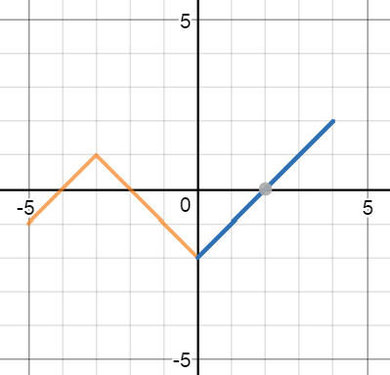
To the right is the graph of f(x). Note: the domain of f(x) is [-5, 4].

f(x) has a lowest point of (0, -2); therefore f(x) has an absolute minimum of -2 (at x = 0).

f(x) has an endpoint at (-5, -1). This is not a relative minimum because it is not the lowest point for a section of the graph beyond itself to the left and right.

f(x) has an absolute maximum of 2 (where x = 4). While (4, 2) is an endpoint, it is also the highest point of all on f(x), so it contains the global maximum of 2.

f(x) has a local maximum of 1 (where x = -3). 1 is the highest y value on the interval (-5, 0) for x.

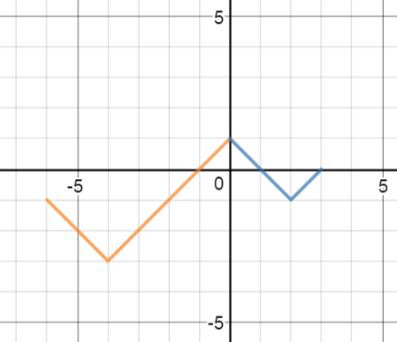
SAMPLE QUESTIONS
Use the graph of g(x) at the right to answer the following questions.

[17] Name the absolute maximum of g(x).

[18] If there are any local maxima of g(x), name them.

[19] Name the absolute minimum of g(x).

[20] If there are any local minima of g(x), name them.

[21] Which points are endpoints and not extrema? Explain your response.

Lesson 1.8 Finding Function Values—PLUS Putting it All Together

Finding a value for f(x) means plugging a value for x into the function and evaluating the expression. Finding an x value for a given function value means plugging a value in for y and solving for x.

EXAMPLE 1.8 A Find f(-8) for f(x) = -x² – 2.

Solution: Plug -8 for x into the formula: f(-8) = -(-8)² – 2 = -(64) – 2 = -66.

EXAMPLE 1.8 B Given g(x) = $\sqrt{25-x^{2}}$ Find x when g(x) = 3.

Solution: Plug 3 in for g(x): 3 = $\sqrt{25-x^{2}}$ . Then solve: Square both sides: 9 = 25 – x²
Subtract 25: -25 -25
-16 = -x²
Multiply by -1: 16 = x²
Take the square root: 4 or -4 = x.
*Check both solutions to see they both work.

SAMPLE QUESTIONS

[22] Given h(t) = 2t³ - $\sqrt{{3t}^{2}-7}$, find h(-2).

[23] Given f(x) = $\sqrt{{2x}^{2}-2}$, find x when f(x) = 4.

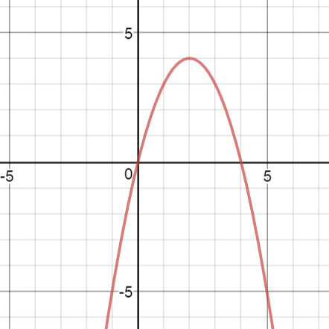
Use the graph of g(x) = -x² + 4x to answer questions 24-30.

[24] Name the x- and y-intercepts of g(x).

[25] Name any extrema of g(x).

[26] Name the end behavior of g(x).

[27] Name g(-1).

[28] Find x when g(x) = 3.

[29] Name the domain and range of g(x).

[30] Name intervals where g(x) is increasing and where g(x) is decreasing.

[31] Which of the following are functions? [a] x² – y = 1 [b] x² – y² = 1 [c] x – y² = 1

SAMPLE QUESTION ANSWERS

Lesson 1.1
[1] The circle is not a function: it does not pass the vertical line test. Also, when x = 0, y has more than one value, and this disqualifies the graph as a function.

[2] This is not a function: when x = -2, y has more than one value.

[3] This is a function: for each x, y has only one value. (It is okay that y is 2 for each x.)

[4] This is not a function: the graph does not pass the vertical line test.

Lesson 1.2
[5] If you graph the function, you will see that x can go as negative or a positive as you allow, so the domain is this: ($-∞,∞$), the set of all real numbers. The lowest point is (0, -6), so the range is this: ($-6,∞$).

[6] The graph continues indefinitely left and right, so the domain is ($-∞,∞$). y has only one value, -1, so (-1) is the range.

[7] The radicand 2x + 1 must be zero or greater; if you solve 2x + 1 > 0, x > -0.5; therefore, the domain is ($-0.5,∞$). The range is ($0,∞$).

Lesson 1.3
[8] g(-1) = 4. y is 4 when x = -1. [9] g(5) = 4. [10] x = 4 and 0 when g(x) = 3.

[11] y goes down 2 as x goes from 0 to 2: $∆y$ = -2 over this interval.

[12] If you follow the graph going left, you can see it rises as x becomes more negative. Therefore g(-10) > g(-5).

Lesson 1.4
[13] Once you graph the function, you should see it decreases in the interval $(-∞, 0)$ and increases in the interval $(0, ∞)$.

[14] g(x) increases in the intervals $(-∞, -3)$ and $(-1, ∞)$. g(x) decreases in the interval (-3, -1).
Notice you do not need to identify y values: you name values on the x-axis.

Lesson 1.5
[15] If you substitute 0 for x, then y = 6: the y-intercept is (0, 6) and this represents how many children can attend the concert if no adults attend. If you substitute 0 for y, then x = 3: the x-intercept is (3, 0), and this represents how many adults can attend the concert if no children attend.

Lesson 1.6
[16] As x approaches $-∞$, y approaches $-∞$; as x approaches $∞$, y approaches $∞$.

Lesson 1.7
[17] The absolute maximum is 1 (where x = 0).

[18] There are no relative maxima.

[19] The global minimum is -3 (where x = -4).

[20] There is a local minimum of -1, on the interval 0 < x < 3.

[21] (-6, -1) and (3, 0) are endpoints. Neither contains an absolute maximum or minimum; g(x) does not continue left beyond (-6, -1) or right beyond (3, 0).

Lesson 1.8
[22] h(-2) = 2(-2)³ - $\sqrt{{3(-2)}^{2}-7}$ = 2(-8) - $\sqrt{12-7}$ = -16 – $\sqrt{5}$. *This is about -18.24, but the exact value is -16 – $\sqrt{5}$. If you want to look at something pretty, search the internet.

[23] $\sqrt{{2x}^{2}-2}$ = 4 ; (STEP 1: Square both sides.) 2x² – 2 = 16; (STEP 2: Add 2.) 2x² = 18;

(STEP 3: Divide by 2.) x² = 9; (STEP 4: Take square root.) x = + 3. (STEP 5: Check solutions.)

[24] The x-intercepts are 0 and 4; the y-intercept is 0.

[25] g(x) has a maximum of 4. [The high point is (2, 4).]

[26] Here is the end behavior for g(x): $\lim_{x→-∞}{-x^{2}+4x}$ = $-∞$ and $\lim_{x→∞}{-x^{2}+4x}$ = $-∞$.
In other words, as x approaches $-∞$, g(x) approaches $-∞$, and as x approaches $∞$, g(x) approaches $-∞$. As x goes more negative, or more positive, y continues to go farther down.

[27] g(-1) = 3.

[28] When g(x) = 3, x = -1 or 3. The graph passes through (-1, 3) and (3, 3).

[29] The function goes left and right forever, so the domain is $(-∞,∞)$. The graph has a maximum of 4 high, so the range is $(-∞, 4]$.

[30] g(x) increases in the interval $(-∞,2)$; g(x) decreases in the interval $(2,∞)$. Notice that as a roller coaster, the graph rises until you reach x = 2.

[31] Choice A is a function, because for each x, y can only be one value. Because y is squared in choices B and C, when x is, say, 3, y can either be positive or negative: y can be more than one value. B and C are not functions.

